INVITATION TO TENDER
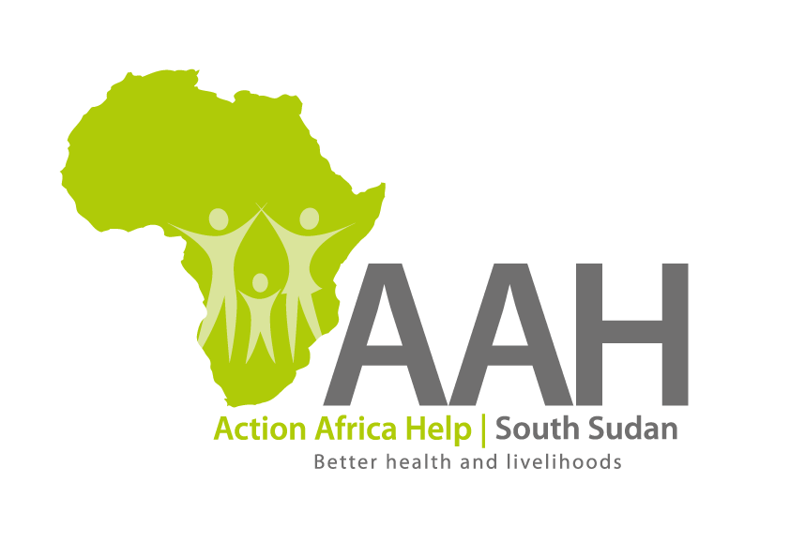

Background
Action Africa Help International (AAH-I) is a nongovernmental and nonprofit making Organization operating in South Sudan with a mission to support disadvantaged Communities to sustainably improve their standard of living through Community empowerment approach in partnership with stakeholders. AAH-I implements Primary Health Care, Agriculture, Humanitarian aid projects and Capacity Building.

The organization is inviting bids from reputable companies for the Supply of Assorted spare parts.

S/N | Description | Part Number
 | Assorted Toyota spare parts | List to be picked from AAH-I Procurement Office or request through email: procurement.southsudan@actionafricahelp.org
More details on the said tender can be picked from AAHI/UNHCR Juba Logistics base during working hours (Monday to Friday, 9:00am to 11.30am and 2:00pm to 4.00pm)

Deadline for submission of the bids will be on 4th December, 2023 at 12:00pm.

