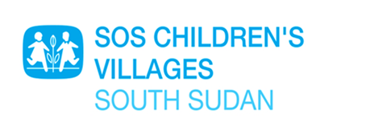

RFQ: DECONSTRUCTION OF MAKESHIP HOUSES AND PREFABRICATED CONTAINERS
Background

SOS Children’s Villages, South Sudan, is calling for quotes from registered South Sudanese construction companies to implement the deconstruction/ demolition of 9 (Nine) make ship facilities previously used as family houses, 6 (Six) locally constructed kitchen, 5 toilets, 1 meeting hall, 1 library and 2 water tanks towers .

SOS Children’s Villages South Sudan, is an affiliate member of SOS Children’s Villages International, a federation of 137 national associations, working together with a single mission: to ensure that every child grows with love, respect and security.

Interested applicants should submit their applications to SOS Children Villages Office located inside FALCON Facility along Yei road 300 meters from the AIDS Commission.
Those interested can either submit their applications, in a shield envelope to the above location or send soft copies by email to the following;

Taban.Gabriel@sos-southsudan.org or Isaac.James@sos-southsudan.org
Alternatively, you can call the following Telephone Numbers
Taban Gabriel: 0926701020
Isaac James: 0928774872 Dateline: 31st.05.2023

