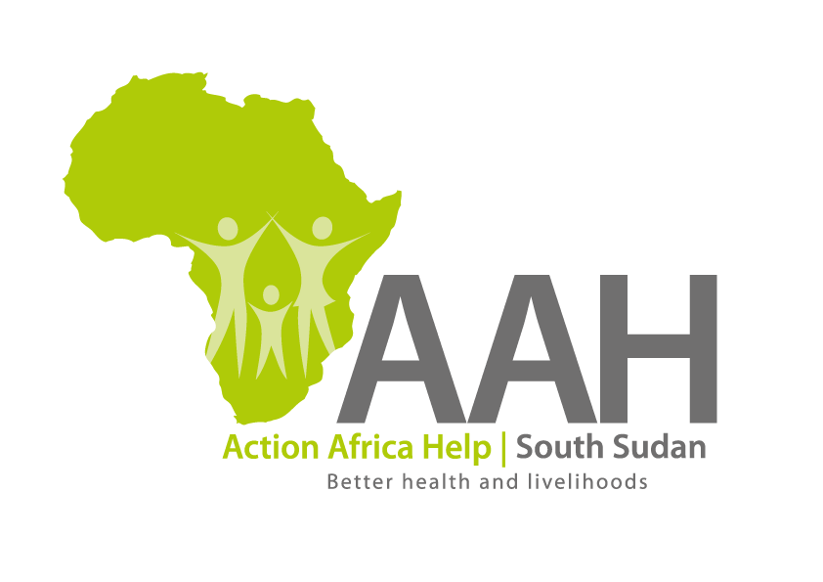
INVITATION TO BID

Background
Action Africa Help International (AAH-I) is a nongovernmental and nonprofit making Organization operating in South Sudan with a mission to support disadvantaged Communities to sustainably improve their standard of living through Community empowerment approach in partnership with stakeholders. AAH-I implements Primary Health Care, Agriculture, Humanitarian aid projects and Capacity Building.

The organization is inviting bids from reputable companies for Bamboo poles.

NO | WORK DESCRIPTION
1 | Provision of labour for supply of bamboo poles (50-70mm diameter and 4-5m length) well sawn and cracks free.

Interested bidders can collect detailed ITB and BOQ from AAHI/UNHCR Logistic base OR request through procurement.southsudan@actionafricahelp.org.

The deadline for the submission of the bids is 29th April, 2026.

