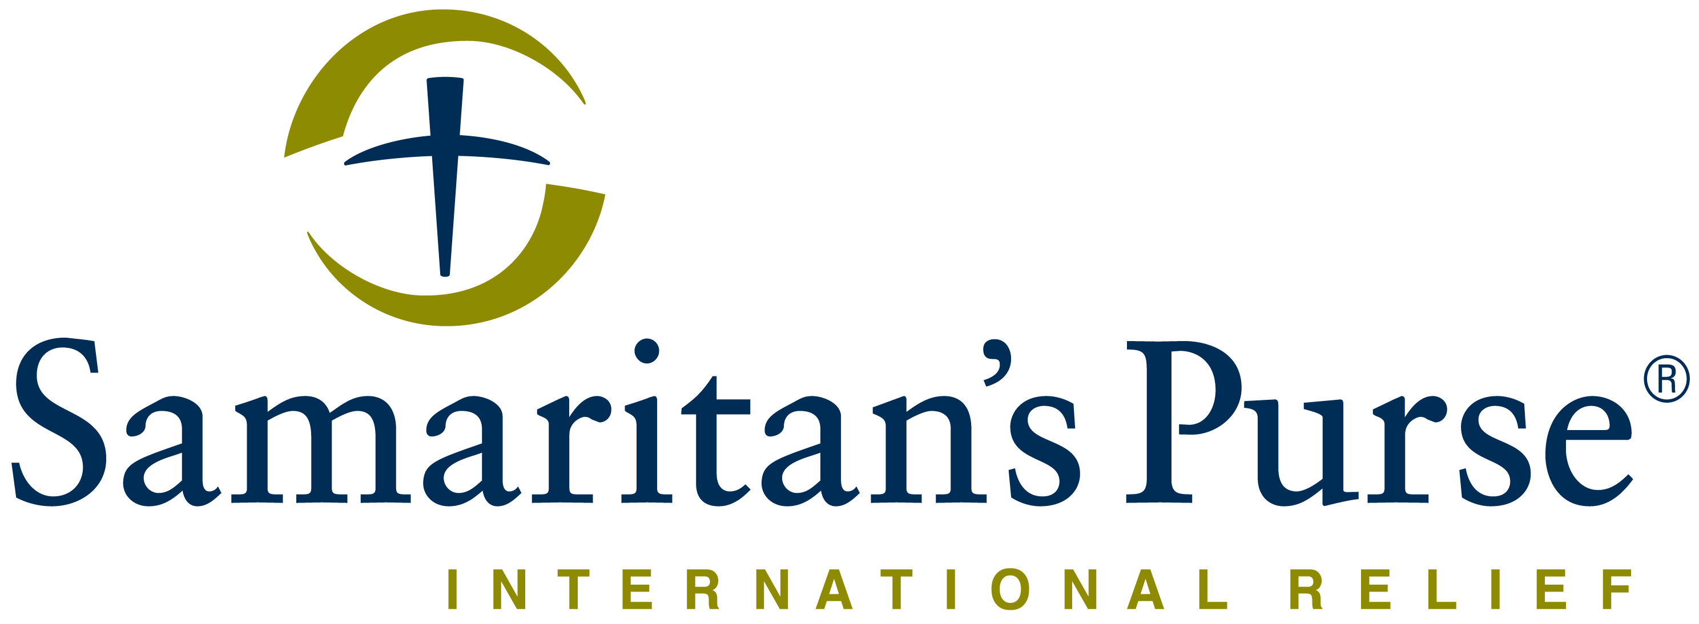
Franklin Graham President

REQUEST FOR QUOTE Date: 09th Oct 2020

Deadline for submission of Quotation is Fri. 23rd Oct 2020 5:00 PM

Samaritan’s Purse wishes to contract a legally recognized service provider (company) to supply NFI items (DDP Juba).

Reference number: LPR10-20-005JBA-T1-2020 FFE Materials

Minimum Qualifications for Bid Consideration:
Due to the quantity of items being purchased, Samaritan’s Purse needs to ensure the capacity of interested suppliers by only reviewing bids from suppliers that can meet the following minimum qualifications:

- Annual sales of greater than $250,000 USD.
- Provide a purchase order of similar items of at least $30,000 USD.
- Must be willing to accept payment after delivery.
- Must provide physical samples of all items to either the SP South Sudan Juba office, SP Kenya Nairobi office, or SP Uganda Kampala office no later than Friday October 23rd at 5:00PM.
- Must complete all attached vetting documents with your bid submission.
- Must provide clear details on delivery lead time, payment terms, and delivery terms (DDP Juba)
- Preference will be given to suppliers who are able to deliver all items to Juba office by November 30th.

Item # | Qty | Unit | Item Description | Unit Cost | Total Cost | Specifications
1 | 38,142 | Pcs | Metal cup |  |  | Stainless steel cups (with handle and roll border edge, polished finish of 8cm diameter x 7cm height)
2 | 38,142 | Pcs | Plate |  |  | Plates (stainless steel) – at least 18cm in diameter
3 | 38,142 | Pcs | Spoon |  |  | Table spoon (stainless steel) 10ml each.
4 | 408 | Pcs | Mat for sitting |  |  | Mat (Plastic mat of 180 cm x 600 cm, or if unavailable, multiple mats of a smaller size to provide the same surface area coverage)

Your bid must also clearly indicate:
- Payment terms
- Delivery terms
- Delivery lead time

IMPORTANT NOTES:
- You must complete the attached vetting forms in this tender and submit together with your quotation. Failure to do so will lead to disqualification of your proposal.
  - 1. Supplier INFO Request
  - 2. Pre-Qualification Vetting Form
  - 3. Updated Supplier Vetting Form
  - 4. Signed Supplier Ethical Declaration Code of Conduct

- You are required to submit physical samples to our office in Juba by no later than Friday October 23rd 2020 at 5:00PM. Those who do not have offices in South Sudan can submit their samples to our Kampala or Nairobi offices. Failure to submit physical samples will lead to automatic disqualification of your proposal (No samples will be accepted after the stated deadline). Each provided sample should be clearly labelled with the name of your company.

- You must indicate in your quotation all the required information. If any of the following information is missing from your quotation, your bid will be automatically disqualified:
  - Unit Cost
  - Total Cost
  - Delivery lead time
  - Delivery terms (DDP Juba, if any charges should be clearly stated on quotation)
  - Payment terms (within 30 business days after receipt of goods & invoice)
  - Length of quotation validity
  - Currency of offer (USD)

- Other items to note:
  - Samaritan’s Purse South Sudan is not subject to VAT (All Quotations should be exclusive of VAT costs)
  - Quotes must be stamped, signed and sent as a pdf/picture file or printed and submitted in a sealed envelope with the reference number clearly written on the sealed envelope
  - Quotations that are received after the Deadline Noted at the Top of RFQ will be excluded from consideration
  - Samaritan’s Purse South Sudan has the right to exclude any Quote that doesn’t meet all of the specifications outlined above.

Manner of Submission:

If you are interested in bidding for this tender, please submit your competitive quotation via

- Email to: ssrfq@Samaritan.org with subject line LPR10-20-005JBA-T1-2020 FFE Materials.
- Or by Hand delivery to Samaritan’s Purse Juba office in sealed enveloped clearly marked: LPR10-20-005JBA-T1-2020 FFE Materials
Samaritan’s Purse Juba Office
Juba, South Sudan, Hai Cinema next to
Quality Hotel, Old Juba Town Road.

(If the correct reference number is not included in the subject line of the email or on the envelope the quote will be subjected to rejection. Do NOT copy anyone when submitting your bid.)

Photographs of the quoted items would be appreciated if attached with your quote.

TERMS AND CONDITIONS:

- Samaritan’s Purse accepts no responsibility and is under no obligation to reimburse applicants for the costs associated with preparation of their applications.
- Samaritan’s Purse reserves the right to award the most qualified service provider (contractor) regardless of the lowest price submitted.
- Payment is upon delivery and after preliminary verification of the services/items specified above.
- Samaritan’s Purse reserves the right to award to more than one bidder or to reject all applicants and cancel the solicitation at any time.

Questions & Clarifications:

If you have any questions or need further clarifications on this RFQ, please email: (JJankok@samaritan.org) copying ssrfq@Samaritan.org and <IMakwangudze@samaritan.org>

_____________________________________________________________

Quotations will be REJECTED if:
    - Submitted separately to any other party.
    - Any coercive behaviour is suspected.

All bids are received directly by the Head of the department. It is not possible to influence the decision or outcome. No individual or group can influence decision making.

