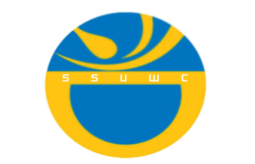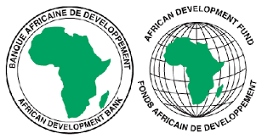 **South Sudan Urban Water Corporation**

Strategic Water Supply & Sanitation Improvement Project - SWSSIP

**SPECIFIC PROCUREMENT NOTICE (SPN):**

**Standard Format for Invitation for Bids**

Date: 20th August 2024

**Grant No: 5800155002201**

**Project Id No: P-SS-E00-003**

IFB No: ***SSUWC-SWSSIP/SUPLS/OCBI/24-25/029***

Title of tender: **SUPPLY OF ONE (1) NO. CESSPOOL EMPTIER TRUCK**

1. The Government of the Republic of South Sudan, has received a Grant from the African Development Fund towards the cost of the “**Strategic Water Supply and Sanitation Improvement Project (SWSSIP).”** and intends to apply part of the proceeds toward payments under the contract for **SUPPLY OF ONE (1) NO. CESSPOOL EMPTIER TRUCK.** The Borrower shall process the payments using the Direct Payment disbursement method, as defined in the Bank’s Disbursement Guidelines and procedures for Investment Project Financing, except for those payments, which the contract provides to be made through letter of credit.”
2. The SOUTH SUDAN URBAN WATER CORPORATION now invites sealed Bids from eligible Bidders for **SUPPLY OF ONE (1) NO. CESSPOOL EMPTIER TRUCK** required within 6 weeks.
3. Bidding will be conducted through the Open Competitive Bidding (International), (OCBI) method as specified in the Bank’s ***Procurement Policy for Bank Group Funded Operations, dated October 2015***, and is open to all eligible bidders as defined in the Procurement Framework.

4. Interested eligible Bidders may obtain further information from South Sudan Urban Water Corporation, Attn: **The Procurement Officer**, ***Strategic Water Supply and Sanitation Improvement Project (SWSSIP)***; and inspect the bidding document during office hours. **0900** to **1700** hours at the address given at No.8 below.

5. The bidding document in English may be purchased by interested eligible Bidders upon submitting a written application to the address below and upon payment of a non-refundable fee of **USD 50** (United States Dollars Fifty only). The payment method will be Cash to South Sudan Urban Water Corporation Cahier. The document will be sent by email, or issued in soft copy as per the bidder’s preference.

6. Bids must be delivered to the address at **no. 8** below on or before **Tuesday 1st October 2024**, at 15**:00 hours** local time. Electronic Bidding will not be permitted. Late Bids will be rejected. Bids will be publicly opened in the presence of the Bidders’ designated representatives and anyone who chooses to attend at the address at no. 8 below on Tuesday 1st October 2024, at 15:15 hours local time.

7. All Bids must be accompanied by a Bid Security of USD 3,000.

8. The address referred to above is:

**Attn: The Procurement Officer,**

**Strategic Water Supply and Sanitation Improvement Project (SWSSIP)**

**South Sudan Urban Water Corporation (SSUWC) Head Office,**

**Behind the Directorate of Nationality Passport and Immigration**

**P. O. BOX 627, Juba, South Sudan**

**E-mail-** [**swissp2019@gmail.com**](mailto:swissp2019@gmail.com)

**Tel: + 211 916728096**