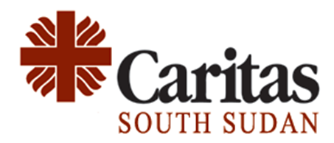
Tender REF: 2023-CSS-029
Caritas South Sudan (CSS) is the official organization of the Catholic Bishops’ Conference of Sudan and South Sudan established in 2011 following the independence of South Sudan. CSS is a member of Caritas Internationalis a confederation of over 160 members and is implementing the WASH, Food Security and Livelihood Project funded by the Ministry of Foreign Affairs of Slovenia. CSS is inviting qualified and reputable companies to submit bids for drilling one borehole in Lafon Eastern Equatoria State and Aweil in Northern Bahr El-Ghazal State.
No | Description
01 | Borehole drilling entails a Geophysical/Hydrogeological Survey report, Hand pump installation, water sample chemical analysis, and Borehole Completion Report.
CSS documents in English will be used during the bidding process and open to all qualified and legally operating companies in South Sudan. Interested companies can collect Request for Quotations (RFQ) at Caritas South Sudan, Juba Office, Juba Palica Compound, P.O.Box 258, from Tuesday, November 28th, 2023, during working hours (9:00 am-4:30 pm). Closing Date and Time for Collection of RFQ: December 5th, 2023 at 3:00 pm Central African Time (CAT).
Compulsory Requirements
Consideration shall be given strictly to bidders who will demonstrate a proven and satisfactory record in the provision of similar services to reputable clients. Key requirements include relevant copies of company legal documents including a valid Drilling Certificate, valid Tax Clearance Certificate, Operational License, Chamber of Commerce License, and Business Registration Certificate.
Submission Requirements:
Sealed Quotations must be received at the CSS Office no later than 10/12/2023 from the date of receiving RFQ Quotations later than this date will not be considered. All sealed bids are to be hand-delivered only in hard copies and marked with the above Tender Reference Number.
Address your bids to:
ATTN. Procurement Committee, CSS
South West of the Chinese Orthopaedics Hospital, Juba Town

