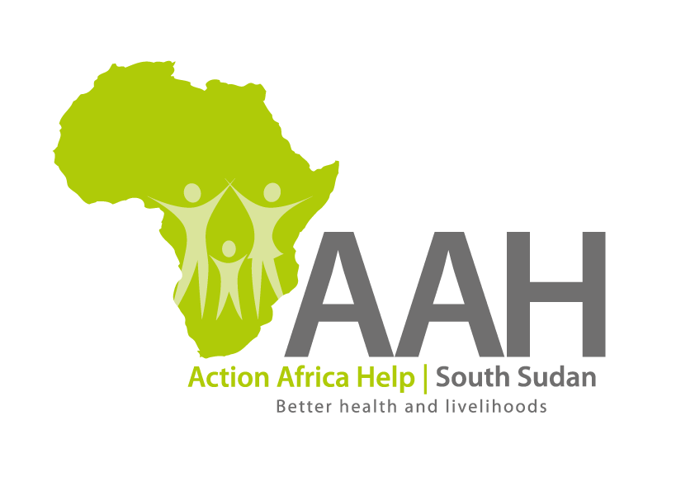
AAHI-South Sudan
Juba Office: Hai Gabat – Opp JIT Supermarket
Behind South Sudan Customs, Tel: +211 925 478 457
Email: ssudan@actionafricahelp.org
Website: www.actionafricahelp.org

INVITATION TO TENDER

Background
Action Africa Help International (AAH-I) is a nongovernmental and nonprofit making Organization operating in South Sudan with a mission to support disadvantaged Communities to sustainably improve their standard of living through Community empowerment approach in partnership with stakeholders. AAH-I implements Primary Health Care, Agriculture, Humanitarian aid projects and Capacity Building.

The organization is inviting bids from reputable companies for the supply of below Supplies.

S/N | Description
1 | Supply of Tractor spare parts and Tyres (PREQ-02494) | Detailed Tender list to be picked from Juba Logistic base
2 | Supply of Toyota Prado Spare Parts (PREQ-02483) | Detailed Tender list to be picked from Juba Logistic base

More details on the said tenders can be picked from AAHI/UNHCR Juba Logistics base during working hours (Monday to Friday, 9:00am to 11.30am and 2:00pm to 4.00pm)

Deadline for submission of the bids will be on 14th June, 2024 at 12:00pm.

