Malteser International
Country Coordination Office
Plot No: 445 Kololo Road 3k South
Tong Ping, Juba Town
South Sudan

11 March 2022

Request for Quotations
RFQ_JUB_2022_0056

For delivery of handwashing facilities to Malteser International warehouse on Bilpam Road in Juba in South Sudan

- Annex 1: Specification of Tendering
- Annex 2: Bill of Quantity

We look forward to receiving your tenders by or before the submission deadline on 18 March 2022 at or before 4:00 pm via E-mail to: mb.procurement-juba@malteser-international.org.

Please write in the Subject line of your email with tender: RFQ_JUB-2022_0056 for handwashing facilities

Thank you for your cooperation.

Sincerely Yours,

Nermin Silajdzic
Country Logistics and Security Cordinator
Plot No. 445, Block 3, Kololo - US Embassy Road.
Central Equitorial State, Juba, South Sudan
M: +211 (0) 911 746 963 · M: +211 (0) 924 767 949
nermin.silajdzic@malteser-international.org · Skype: nsilajdzic
www.malteser-international.org
Malteser International Europe/Malteser Hilfsdienst e. V., County Court Cologne, VR 4726
Executive Board: Karl Prinz zu Löwenstein, Dr. Elmar Pankau,
Douglas Graf Saurma-Jeltsch, Verena Hölken
Legal advice: This communication is for use by the intended recipient and contains information that may be privileged, confidential or copyrighted under applicable law. If you are not the intended recipient, you are hereby formally notified that any use, copying or distribution of this e-mail, in whole or in part, is strictly prohibited. Please notify the sender by return e-mail and delete this e-mail from your systems.
 please consider the environment before printing this email

A. SPECIFICATION OF BIIDING

Related to our advertised the Request for Quotations (RFQs) RFQ_JUB_2022_0056 Malteser International (MI) herewith calls for tenders for delivery of handwashing facilities to Malteser International warehouse on Bilpam Road in Juba in South Sudan.
Under the following reference number:
Donor project numbers: 1373-WAU

Description of the organization and its activities
Malteser International, the worldwide relief agency of the Sovereign Order of Malta for humanitarian aid, has more than 50 years of experience in humanitarian relief and covers around 100 projects in some 20 countries in Africa, Asia and the Americas, annually. It provides aid in all parts of the world without distinction of religion, race or political persuasion. Christian values and the humanitarian principles of impartiality and independence are the foundation of its work.
In South Sudan, Malteser International operates in Juba, Yei, Wau and Uyujuku. In these locations, it’s activities include Health and Nutrition, Food Security and Livelihood, Water Sanitation and Hygiene and Health Programs
Objective of RFQ: In accordance with the overall targets of above-mentioned operations, MI plans to order tenders for delivery of handwashing facilities to Malteser International warehouse on Bilpam Road in Juba in South Sudan.
The technical specifications and conditions of the tendering process are described below in the Specification of Tendering and in the Annex 2: Bill of Quantity which are part of this RfQ.
Suppliers are invited to present tenders complying with the requirements here below specified.

Tender Presentation

The tender shall be via E-mail to: mb.procurement-juba@malteser-international.org

The deadline for the delivery of the tenders is: 18 March 2022 at or before 4:00pm
- The tender shall be written in English
- The tender should be valid for 30 days after the deadline
- The format BoQ can be used or a separate one depending on supplier’s choice.

General conditions
- The tender shall be typed or written and signed on each page by the legal representative of the supplier,
- The winning supplier might be requested to provide catalogues, pictures, technical descriptions and/or samples of items at the order stage when required,
- The prices of the tenders will be expressed in United States Dollars. The prices must be on unit price basis as well as by totals,
- The prices will be considered fixed. No additional change of whatsoever nature and type will be accepted by Malteser International,
- MI reserves the right to accept or reject all tenders depending on prevailing condition at the time.

Technical specification
No | Supplies | Quantity | Unit | Quality
1 | 50 liters handwashing facility (Rotor type) with metallic stand as per attached specification | 90 | Pcs | Good

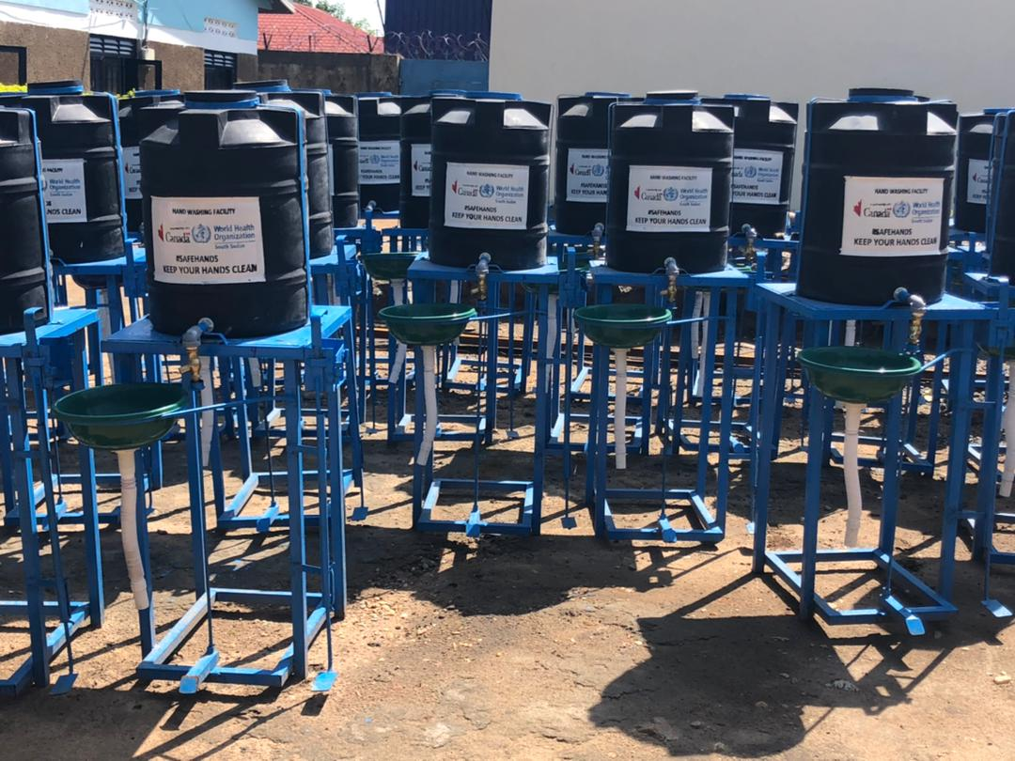

Material schedule for foot pedal operated hand washing station
No | Item description | Unit | Quantity
1 | 50 Litres Plastic water storage tank (ROTO Type) | Pcs | 1
2 | Lever/push/pull tap | Pcs | 1
3 | MS Flat steel plate for tank, basin and soap dispenser base; 5mm thick and 1m2 size plate | Pcs | 1
4 | Wash basin/bucket c/w wastewater drainage pipe 1”Ø | Pcs | 1
5 | MS Square hollow tubes: 2”x2” 6m length for the HWS pedestal  (horizontal and vertical members) fabricated on 0.5 - 1m high stand | Pcs | 2
6 | MS Square rod; 1x1” and 1m long for the HWS foot pedals | Pcs | 2
7 | Welding rods and other fittings/accessories; coil spring, lubricating grease | Item | 1
8 | Paint and visibility work | Litres | 1

Validity of tenders
Each company is bound to the tender submitted for a period of 30 days from the deadline for submission of tenders.

Language of tenders
All tenders, official correspondence between companies and MI, as well as all documents associated with the tender request will be in English.

Submission of tenders
All tenders must conform to the following conditions:

Each tender must submitted via E-mail to: mb.procurement-juba@malteser-international.org on 18 March 2022, at or before 04:00 pm (local time).

Content of tenders
All submitted tenders must conform to the requirements mentioned in the RFQ. Furthermore, they must include the following documents:
Part 1 - Tender: A tender for the bided delivery of handwashing facilities MI warehouse on Bilpam Road in Juba in South Sudan. The format BoQ can be used or a separate one depending on supplier’s choice. Additional sheets may be attached for further details.
Part 2 - Legal documents
- Copy of the company’s certificate of incorporation,
- Copy of Chamber of Commerce registration,
- Copy Tax Identification Certificate,
- Copy of Certificate of Operation,
- Company’s Bank Statement of last three months,
- Company’s official address,
- Bank account details (where money would be paid),

Ownership of tenders
MI reserves/funds ownership of all tender received. As a consequence, bidders will not be able to stipulate requirements that their tenders are to be returned.
- Opening of submitted tenders
The tenders will be opened on 18 March 2022 in MI Country Coordination Office in Juba, South Sudan, by the Evaluation committee. The selection process will be recorded in writing by the committee.

Tenders evaluation
The criteria applied for the evaluation will be the legal conformity, the price, the technical experiences, the compliance with technical specifications and quality standards, and the capacity to deliver, delivery time and meet timeframes as specified. The work will be awarded to the winning bidder according to the timetable mentioned above.
- Exclusion criteria
The following are exclusion criteria:
- Not submitted the following company registration documents in South Sudan:
    - Copy of the company’s certificate of incorporation,
    - Copy of Chamber of Commerce registration,
    - Copy Tax Identification Certificate,
    - Copy of Certificate of Operation,
- Not bided according to the specification and
- Mathematical error of total bided price >±2 %.

- Specific Technical and Financial Evaluation Criteria to standards:
- Comparative Bid Analysis and justification basing on responsiveness of the selected supplier by evaluation committee.
- Contract agreement will directly be issued to the selected supplier upon approval.

- Terms of payment
The payment will be done in United States Dollar by bank transfer or cheque as specified below:
- Payment terms will be within 10 business days after receipt of goods and invoice, by Electronic bank transfer.
Annex 2: Bill of Quantity
For delivery of handwashing facilities to Malteser International warehouse on Bilpam Road in Juba in South Sudan
No | Description | Unit | Quantity | Unit price USD | Total USD
1 | 50 liters handwashing facility (Rotor type) with metallic stand as per attached specification. | Pcs | 90

On behalf of Malteser International:

11 March 2022
Sincerely,

Nermin Silajdzic
Country Logistics and Security Coordinator
Plot No. 445, Block 3, Kololo - US Embassy Road.
Central Equitorial State, Juba, South Sudan
M: +211 (0) 911 746 963 · M: +211 (0) 924 767 949
nermin.silajdzic@malteser-international.org · Skype: nsilajdzic
www.malteser-international.org
Malteser International Europe/Malteser Hilfsdienst e. V., County Court Cologne, VR 4726
Executive Board: Karl Prinz zu Löwenstein, Dr. Elmar Pankau,
Douglas Graf Saurma-Jeltsch, Verena Hölken
Legal advice: This communication is for use by the intended recipient and contains information that may be privileged, confidential or copyrighted under applicable law. If you are not the intended recipient, you are hereby formally notified that any use, copying or distribution of this e-mail, in whole or in part, is strictly prohibited. Please notify the sender by return e-mail and delete this e-mail from your systems.
 please consider the environment before printing this email

