INVITATION TO TENDER
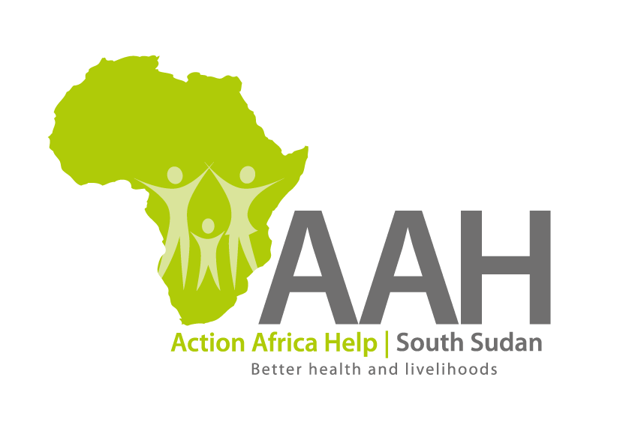
Background
Action Africa Help International (AAH-I) is a nongovernmental Organization and nonprofit making operating in South Sudan with a mission to support disadvantaged Communities to sustainably improve their standard of living through Community empowerment approach in partnership with stake holders. AAH-I implements Primary Health Care, Agriculture, Humanitarian aid projects and Capacity Building.

The organization is inviting bids from competent and reputable Companies for the Supply of Assorted ICT items and batteries.

Tender 1
 | Description of Goods/Services | Part Number | QTY(Pcs)
1 | Battery ( Victron energy battery 12v /200Ah) | Victron brand | 10

Tender 2

s/n | Description of goods/services | Quantity
1 | ICT and CCTV Items | Assorted

More details on the ICT and CCTV tenders can be picked from AAHI/UNHCR Juba Logistics base during working hours (Monday to Friday, 9:00am to 11.30am and 2:00pm to 4.00pm)

Deadline for submission of the bids will be on Thursday 27th July, 2023 at 12:00pm.

