Malteser International Europe, Grüner Weg 14, 50825 Cologne, Germany

Malteser International
South Sudan Coordination office
Plot No. 445, Block 3, Kololo - US Embassy Road.
Central Equatorial State, Juba,
South Sudan
Date: 29 September /2020
Request for quotations
RFQ-JUB-2020-0189

For supply and delivery of Toyota Hiace Commuter Bus 15-Seater – 4×2 – Model LH202L/R-REMDE (IAPB), 2.5L Diesel Engine 4 Cylinders (non-turbo), Air conditioning.

- Annex 1: Specification of Bidding
- Annex 2: Bills of Quantity

We look forward to receiving your tenders by or before the submission deadline on 9 October 2020 at or before 4:00pm via email to mb.procurement-juba@malteser-international.org

Thank you for your cooperation.

Sincerely Yours,

Nermin Silajdzic
Country Logistics and Security Coordinator
Plot No. 445, Block 3, Kololo - US Embassy Road.
Central Equitorial State, Juba, South Sudan
M: +211 (0) 911 746 963 · M: +211 (0) 924 767 949
nermin.silajdzic@malteser-international.org · Skype: nsilajdzic
www.malteser-international.org
Malteser International Europe/Malteser Hilfsdienst e. V., County Court Cologne, VR 4726
Executive Board: Karl Prinz zu Löwenstein, Dr. Elmar Pankau,
Douglas Graf Saurma-Jeltsch, Verena Hölken
Legal advice: This communication is for use by the intended recipient and contains information that may be privileged, confidential or copyrighted under applicable law. If you are not the intended recipient, you are hereby formally notified that any use, copying or distribution of this e-mail, in whole or in part, is strictly prohibited. Please notify the sender by return e-mail and delete this e-mail from your systems.
Please consider the environment before printing this email

- Specification

S/No | Specification
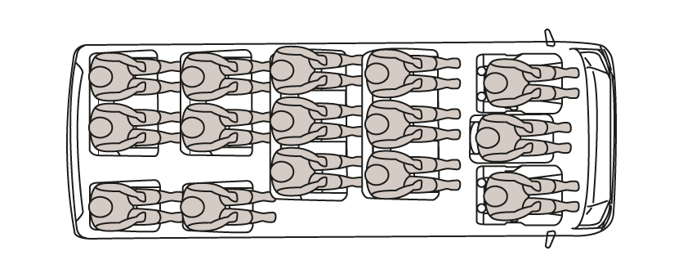

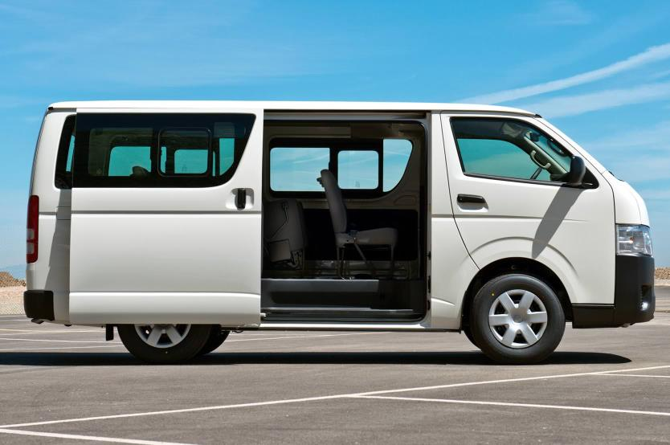

1 | Toyota Hiace Commuter Bus 15-Seater – 4×2 – Model LH202L/R-REMDE (IAPB), 2.5L Diesel Engine 4 Cylinders (non-turbo), Air conditioning,

1 | Model code | LH202-REMDE
2 | Drive | 4x2
3 | Transmission | Manual
4 | Speed | 5
5 | Front suspension | Double wishbone
6 | Rear suspension | Leaf
7 | Front brakes | Disc
8 | Rear brakes | Drum
9 | Number of doors | 4
10 | Number of seats | 15
11 | Seat material | Fabric
12 | Color | White
13 | Engine model
14 | Engine model | 5L-E
15 | Displacement | 2986
16 | Number of cylinders | 4
17 | Maximum power (kw/rpm) | 70/4000
18 | Maximum power (bhp/rpm): | 94/4000
19 | Maximum torque (Nm/rpm) | 197/2200
20 | Electrics (volts) | 12
21 | Fuel Type | Diesel
22 | Fuel tank capacity (Liters) | 70
23
Engine related standard features
1 | 120 Amp alternator (12v) | Power steering
2 | Battery: 85D26 x2 (55A/Hx2) | Semi-floating rear axle
3 | Engine & Chassis
4 | Engine model | 5L-E
5 | Displacement | 2986
6 | Number of cylinders | 4
7 | Maximum power (kw/rpm) | 70/4000
8 | Maximum power (bhp/rpm): | 94/4000
9 | Maximum torque (Nm/rpm) | 197/2200
10 | Electrics (volts) | 12
11 | Fuel Type | Diesel
12 | Fuel tank capacity (Liters) | 70
Engine related standard features
1 | 120 Amp alternator (12v) | Power steering
2 | Battery: 85D26 x2 (55A/Hx2) | Semi-floating rear axle
3 | Cold area package | Severe usage package
4 | Cyclone and pre-cleaner type air cleaner
5 | Tyres
6 | Front tyres | 195R15C 8PR
7 | Rear tyres | 195R15C 8PR
8 | Tyre type | Radial
Interior features
1 | Air cooler: (A/C=cooler + heater) FR+RR (two-tier register) | Interior lights
2 | Ashtray | Interior rear-view mirror (day and night)
3 | Assist grips - front & rear | Parking brake warning light
4 | Brake fluid level warning | Pre-wiring for audio with 2 speakers and antenna
5 | Cigarette lighter | Rear window defogger
6 | Clock: digital | Seat belts: front x 3 (2 x 3 point & 1 x 2 point)
7 | Dashboard-mounted gear lever | Seat belts: rear x 11 (2 point)
8 | Door pockets: front doors | Speedometer km/h
9 | Front door armrests x 2 | Steering wheel lock
10 | Fuel gauge | Sun visors D&P
11 | Fuel level warning light | Timing belt replacement warning light
12 | Fuel lid opener switch (no key) | Trip Meter
13 | Fuel sedimented warning | Vinyl floor covering
14 | Glove box: w/o lock | Water temperature gauge
15 | Headrests: front (D+P)
Exterior features
1 | Bumper: front & rear | Outside rear view mirror - Door
2 | Front stabilizer bar | Rear window wiper - w/washer
3 | High mount stop lamp | Semi-sealed halogen headlamps
4 | High/Low 2-speed windshield wipers (intermittent/washer lnk) | Sliding side passenger door
5 | Lift-up type back door | Towing: front only (eye)
6 | Mud guards: front & rear | Windshield - green laminated
Safety and Security
1 | Central door locking - (FR: SLIDE:BACK) D+P side key linked
Miscellaneous
1 | Owner's manual - English | Tool Kit & Jack

Description of the organization and its activities

Malteser International, the worldwide relief agency of the Sovereign Order of Malta for humanitarian aid, has more than 50 years of experience in humanitarian relief and covers around 100 projects in some 20 countries in Africa, Asia and the Americas, annually. It provides aid in all parts of the world without distinction of religion, race or political persuasion. Christian values and the humanitarian principles of impartiality and independence are the foundation of its work.
In South Sudan, Malteser International operates in Juba, Yei, Wau, Maridi and Rumbek. In these locations, it’s activities include Health and Nutrition, Food Security and Livelihood, Water Sanitation and Hygiene and Health Programs
Objective of the RFQ:
In accordance with the overall targets of the above-mentioned operations Malteser International Request for Quotation for supply and delivery of Toyota Hiace Commuter Bus 15-Seater – 4×2 – Model LH202L/R-REMDE (IAPB), 2.5L Diesel Engine 4 Cylinders (non-turbo), Air conditioning Under project No. 1295-CGN-2020

The technical specifications and conditions of the tender is fully described in Annex 2:
Competent and qualified companies are therefore invited to present bids complying with the requirements specified.

Tender Presentation
The Tender will be delivered to the following Email Address
mb.procurement-juba@malteser-international.org
Any tender that will be submitted by hand delivery will not be accepted.
The deadline for the submission of the tender is 9th October 2020before at or before 4:00pm.
- The tender shall be written in English.
- The tender should be valid for 30 days after the deadline.
- The formatted BOQ can be used or a clear separate one depending on supplier’s choice.

General conditions
- The tender shall be typed or written and signed on each page by the legal representative of the supplier,
- The winning company might be requested to provide catalogues, pictures, technical descriptions and/or samples of items at the order stage when required,
- The prices of the tender will be expressed in United States Dollars.
- The prices must be on unit price and total basis.
- The prices will be considered fixed whereas Malteser International will not process Tax exemption. No additional change of whatsoever nature and type will not be accepted by Malteser International;
- Malteser International reserves the right to accept or reject all tenders depending on prevailing condition at the time,
- Timetable
Activities | Date | Time*
Deadline for submission of tenders | 9th October 2020 | 4:00 P.M.
Opening of submitted tenders | 12th October 2020
Notification of award to the successful tenderers | 14thOctober 2020
Signature of Contract Agreement | 15th October 2020

Validity of tenders
Each company is bound to the tender submitted for a period of 30 days from the deadline for submission of bids.

Language of tender
All tenders, official correspondence between companies and Malteser International, as well as all documents associated with the tender request will be in English.

Submission of tenders
All tenders must conform to the following conditions:
Each tender must be Delivered to mb.procurement-juba@malteser-international.org
With refrence Number PRF-JUB-2020-0189

Content of tender
All submitted tenders must conform to the requirements mentioned in the RFQ. Furthermore, they must include the following documents:

Part 1 - Tender: A tender
The formatted BoQ can be used or a separate one depending on supplier’s choice. Additional sheets may be attached for further details.
Part 2 - Legal documents
- Copy of the company’s certificate of incorporation,
- Copy of Chamber of Commerce registration,
- Copy of Tax Identification Certificate,
- Copy of Certificate of Operation,
- Company’s Bank Statement of last three months,
- Company’s official address,
- Bank account details (where money would be paid)

Ownership of tenders
Malteser International reserves/funds ownership of all tenders received. Consequently, tenderers will not be able to stipulate requirements that their bids are to be returned.
- Opening of submitted tenders
The Evaluation Committee will evaluate the tenders on 12thOctober 2020 in Malteser International Juba office MI Office in Juba, South Sudan. The Evaluation Committee will record the selection process in writing indoor.

Tender evaluation
The criteria applied for the evaluation will be the legal conformity, the price, the technical experiences, the compliance with technical specifications and quality standards, and the capacity to deliver, delivery time and meet timeframes as specified. The Services will be awarded to the winning tenderer according to the timetable mentioned above.
- Specific Technical and Financial Evaluation Criteria to standards:
Comparative bid analysis and justification basing on responsiveness of the selected supplier by evaluation committee. Contract Agreement will be issued to the selected supplier upon approval.

- Delivery
The Items will be delivered to following Location:
Malteser International South Sudan Coordination office, Plot No. 445, Block 3, Kololo - US Embassy Road.Central Equatorial State, Juba, South Sudan.
Terms of payment
The payment would be under project 1295-CGN In United States Dollar by bank transfer or cheque as specified below:
Payment will be done after ten days of complete delivery and Received of delivery Note /GRN
Annex 2: Bill of Quantity
No. | Category | Unit | Quantity | Total price USD
1 | Toyota Hiace Commuter Bus 15-Seater – 4×2 – Model LH202L/R-REMDE (IAPB), 2.5L Diesel Engine 4 Cylinders (non-turbo), Air conditioning, | pc | 1

On behalf of Malteser International: Date: 29 September 2020

Yours faithfully,

Nermin Silajdzic
Country Logistics and Security Coordinator
Plot No. 445, Block 3, Kololo - US Embassy Road.
Central Equitorial State, Juba, South Sudan
M: +211 (0) 911 746 963 · M: +211 (0) 924 767 949
nermin.silajdzic@malteser-international.org · Skype: nsilajdzic
www.malteser-international.org
Malteser International Europe/Malteser Hilfsdienst e. V., County Court Cologne, VR 4726
Executive Board: Karl Prinz zu Löwenstein, Dr. Elmar Pankau,
Douglas Graf Saurma-Jeltsch, Verena Hölken
Legal advice: This communication is for use by the intended recipient and contains information that may be privileged, confidential or copyrighted under applicable law. If you are not the intended recipient, you are hereby formally notified that any use, copying or distribution of this e-mail, in whole or in part, is strictly prohibited. Please notify the sender by return e-mail and delete this e-mail from your systems.
Please consider the environment before printing this email

