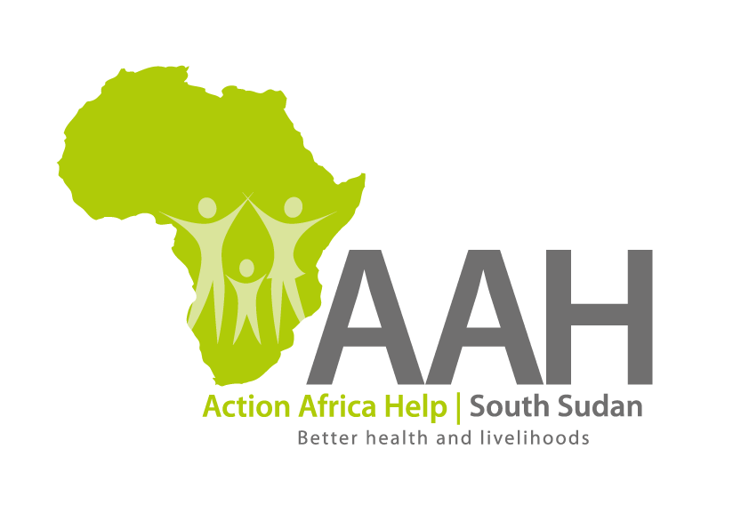
INVITATION TO TENDER

Background
Action Africa Help International (AAH-I) is a nongovernmental Organization and nonprofit making operating in South Sudan with a mission to support disadvantaged Communities to sustainably improve their standard of living through Community empowerment approach in partnership with stake holders. AAH-I implements Primary Health Care, Agriculture, Humanitarian aid projects and Capacity Building.

The organization is Inviting bids from competent and reputable companies for fuel stations maintenance with an intention of getting into a long term Frame work agreement.

Detailed tender document to be picked from AAHI/UNHCR Juba Logistic base.
The deadline for submission is on 12th June, 2023.

