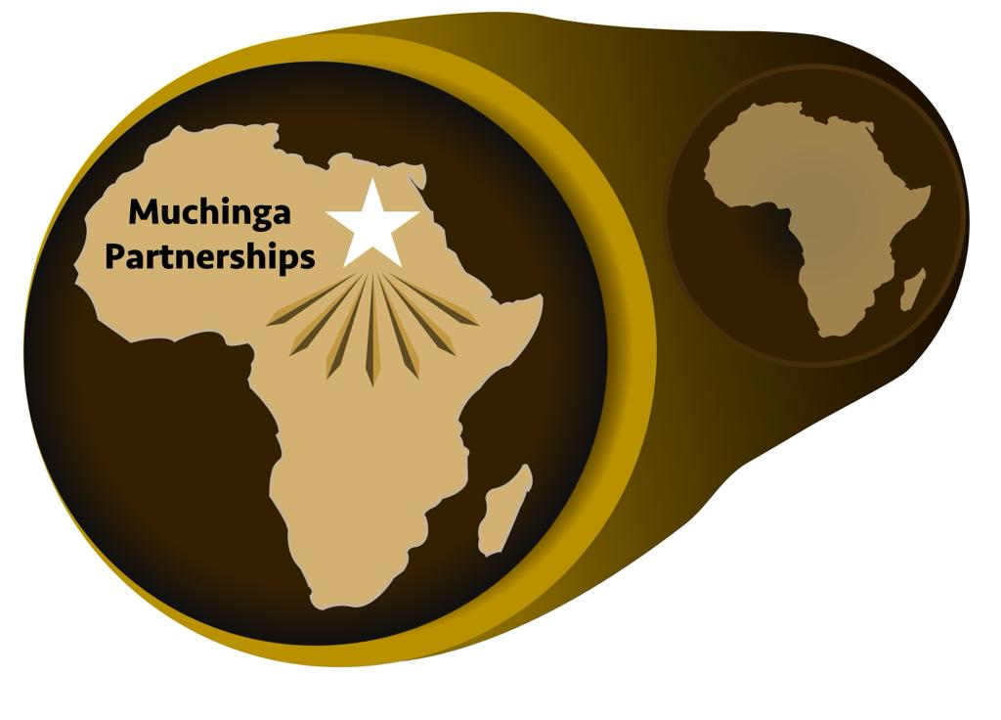

APPLICATION FORM
Muchinga Partnerships Application Process July / August 2021
- It is an open applications process. All applications are to be submitted before the cut-off date.
- Application is a simple three page application including a Concept Note. Total submissions including attachments must not exceed 8 pages. Longer submissions may be rejected, shorter ones are encouraged.
- Applications are reviewed for the following criteria:
  - Does applicant have a viable business model that leads to growth and impact?
  - What are the direct, measurable impacts on low income, grassroots Africans?
    - The impacts for low income people need to include such things as income, jobs and/or other direct benefits like access to power or ability to start a small business.
  - Does the application show that this level of support will help unlock pathway to growth and profitability and more social impact.
  - What the the exact outcomes/deliverables from the funding?
  - What matching funds will be brought by the organization, in what form and how it will be verified.
  - Is the organization led or focused in any way on women, youth and/or people with disabilities. All small organizations are open to apply.
- Once the initial application is accepted, the Organization is to agree to work with Muchinga Partnerships to further evaluate and assess the organization and its needs and roadblocks to growth and success.
- Selected organizations and Muchinga will sign an agreement outlining their partnership with Muchinga and FYI, Muchinga's local implementing partner. The agreement will also specifically lay out how they will work together with their partners. The agreement will also spell out exactly how the organization will report including how it will report on its deliverables, outcomes and timing.
- Muchinga and/or FYI will act as advisors and mentors to the Organization focusing on what is needed to expand and grow and reach more impact.
- The first result of this partnership will be a rewritten business plan that includes the support from Muchinga and what exactly will result from the financial support.
- Next steps in the partnership beyond the initial funding period will be specified.

Application Form
Muchinga Partnerships / Foundation for Youth Initiatives
This application is for funding of up to $5,000 to support a small organization/entrepreneur to significantly increase their sales and income and increase its' benefits to low income people, increases in products bought from them or through increased jobs. No start-ups will be accepted; the applicant must be a for profit organization, must have some a proven concept and some track record of success. The organization should bring matching funds (specific in kind contributions may be accepted) to the project, at least equal to the amount of the requested Muchinga funding. Women, youth and people with groups of disabilities will be considered as well as others. Organization or its project should be located within 100 kilometers of Juba.
Name of Organization:
Primary Contact:
Contact Information:
Physical Address:
Phone number:
Email address:

SUBMISSIONS FOR APPLICATION
1. Summary of the organization's track record of success.

2. Summary of Proposed Project (50 words or less):

3. Specifics for what funds will be used for:

4. Specifics for Outcomes/Impact of funding
  - Specific business outcomes - E.G. Sales will increase by $5,000 between months 6 and 9 of having received the funding.
  - Specific Outcomes/Impact on low income people/grassroots populations social benefits including jobs, income to grassroots, etc.. E.G. Purchases of crops form low income people will be >$5,000 the third three month period. And/or three full time jobs will be created.

5. Duration of project: Suggested (12 months or less)

6. Amount Requested from Muchinga (in local currency):
________________

7. Amount of matching funds or Organization's contribution
________________

NOTE: SUBMISSION ON ITEMS 1-7 ARE NOT TO EXCEED 3 PAGES TOTAL. IT IS IMPORTANT YOUR SUBMISSION IS CLEAR AND ABOVE ALL SUCCINCT.

8. Attached a Concept Note (MAXIMUM ONE PAGE) describing the project and its' expected outcomes.

9. Attached a business plan or any other relevant documents. (NOT TO EXCEED FIVE PAGES)

10. Attach a copy of organization's registration document. The applicant must be a for profit organization.

11. Provide three performance references. Each reference must include the name, title, telephone number, and e-mail address of the contact person.

12. Applications should be submitted by e-mail to SouthSudanApplications@muchinga.org. Applications will begin to be accepted July 23.
The submission deadline is August 13, 2021. Applications received after the closing date will not be considered.

13. Next steps:
a) Review of applications August 13 - 18, 2021
b) Shortlisted finalists selected. August 18, 2021
c) Project design and development . Muchinga and FYI to meet with finalists - August 17 - 19, 2021
d) Final selection of enterprises and Signing of Grant Agreements - August 20

