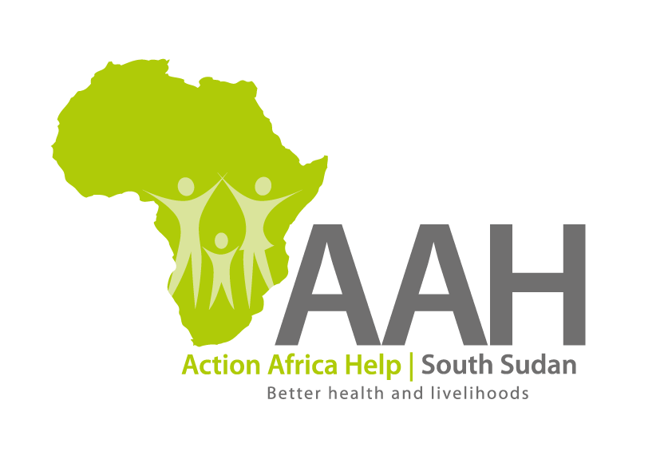

|  |
| --- |
| **INVITATION TO BID** |

Background

Action Africa Help International (AAH-I) is a nongovernmental and nonprofit making Organization operating in South Sudan with a mission to support disadvantaged Communities to sustainably improve their standard of living through Community empowerment approach in partnership with stakeholders. AAH-I implements Primary Health Care, Agriculture, Humanitarian aid projects and Capacity Building.

The organization is inviting bids from reputable companies for supply and installation of the following activities.

|  |  |
| --- | --- |
| **NO** | **WORK DESCRIPTION** |
| 1 | Installation of integrated 100 solar led standalone security lights in Jamjang camp (costs to include labor, supply of materials, delivery and completion of installation of solar led stand-alone security lights in Jamjang ). |
| 4 | Proposed solarization of Youth center in Ajuong Thok refugee camp (Costs to include labor, supply of materials, delivery and completion of solarization at the youth Centre in Ajuong Thok |

Interested bidders can collect detailed ITB and BOQ from AAHI/UNHCR Logistic base OR request through [procurement.southsudan@actionafricahelp.org](mailto:procurement.southsudan@actionafricahelp.org).

The deadline for the submission of the bids is 17th October, 2025.