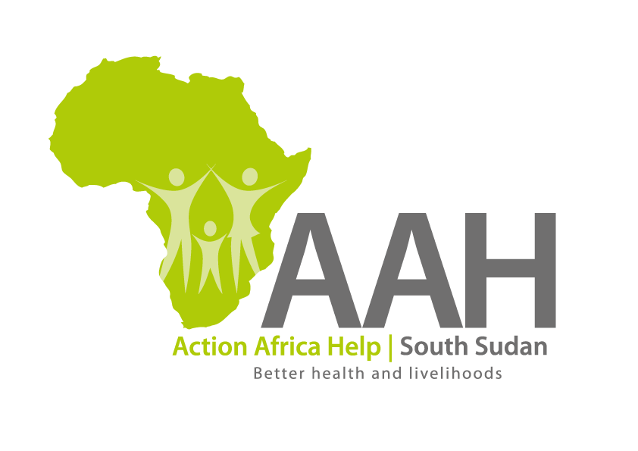
INVITATION TO BID

Background
Action Africa Help International (AAH-I) is a nongovernmental and nonprofit making Organization operating in South Sudan with a mission to support disadvantaged Communities to sustainably improve their standard of living through Community empowerment approach in partnership with stakeholders. AAH-I implements Primary Health Care, Agriculture, Humanitarian aid projects and Capacity Building.

The organization is inviting bids from reputable companies for various construction services in Jamjang.

NO | WORK DESCRIPTION
1 | Fabrication and supply of various windows and doors
2 | Proposed maintenance of the existing judges' office block and construction of one room external toilet block in Pariang.
3 | Proposed repair of existing 260m long chain-link fence and extension of existing milling facility at seed store in Pamir

Interested bidders can collect detailed ITB and BOQ from AAHI/UNHCR Logistic base OR request through procurement.southsudan@actionafricahelp.org.

The deadline for the submission of the bids is 10th October, 2025.

