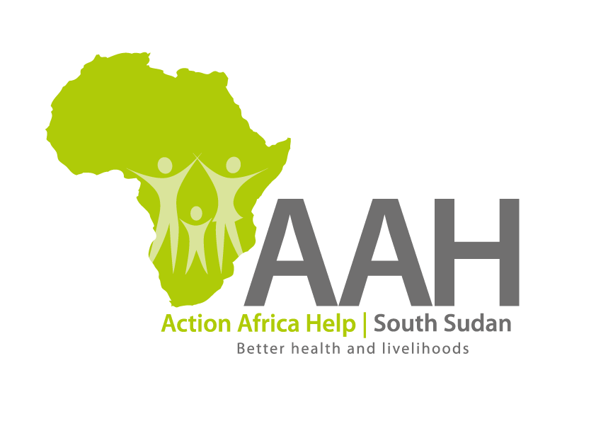
AAHI-South Sudan
Juba Office: Hai Gabat – Opp JIT Supermarket
Behind South Sudan Customs, Tel: +211 925 478 457
Email: ssudan@actionafricahelp.org
Website: www.actionafricahelp.org

INVITATION TO TENDER

Background
Action Africa Help International (AAH-I) is a nongovernmental and nonprofit making Organization operating in South Sudan with a mission to support disadvantaged Communities to sustainably improve their standard of living through a Community empowerment approach in partnership with stakeholders. AAH-I implements Primary Health Care, Agriculture, Humanitarian aid projects, Capacity Building and Education.

The organization is calling for quotations from reputable companies for the supply of Food & Non-food items for Maridi Nursing Training School.

 | DETAILS | LOCATION OF THE TENDER
1 |  | Tender details to be picked from AAHI/UNHCR Logistic Base Juba Town

The deadline for submission of the bid is Tuesday 27th of September,2022.

More information on the tender to be picked from AAHI/UNHCR Juba logistic Base Juba Town.

