VIVO Electric 71 x 36 inch Standing Desk Workstation, Memory Controller Height Adjustment, 1B Series, Black Top Black Frame, DESK-KIT-1B7B-36

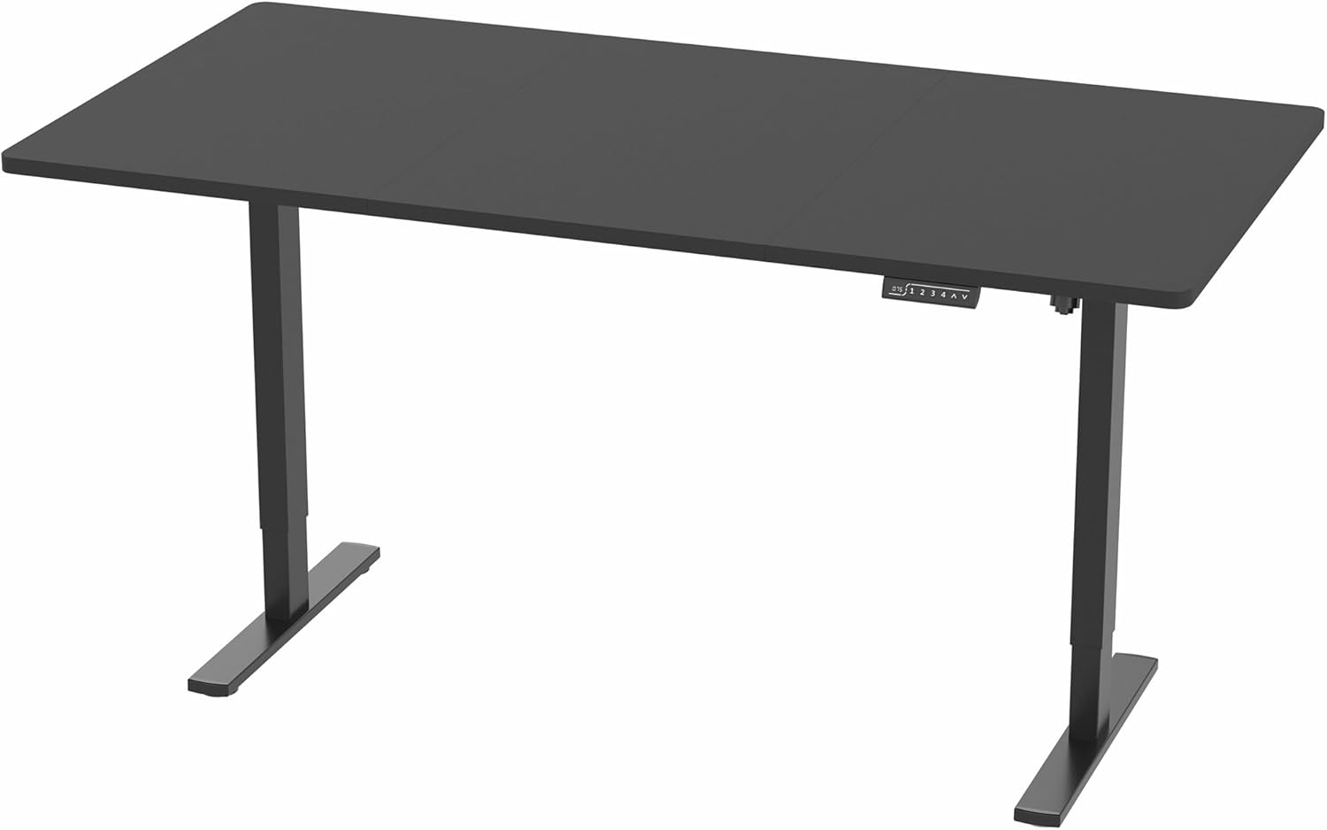

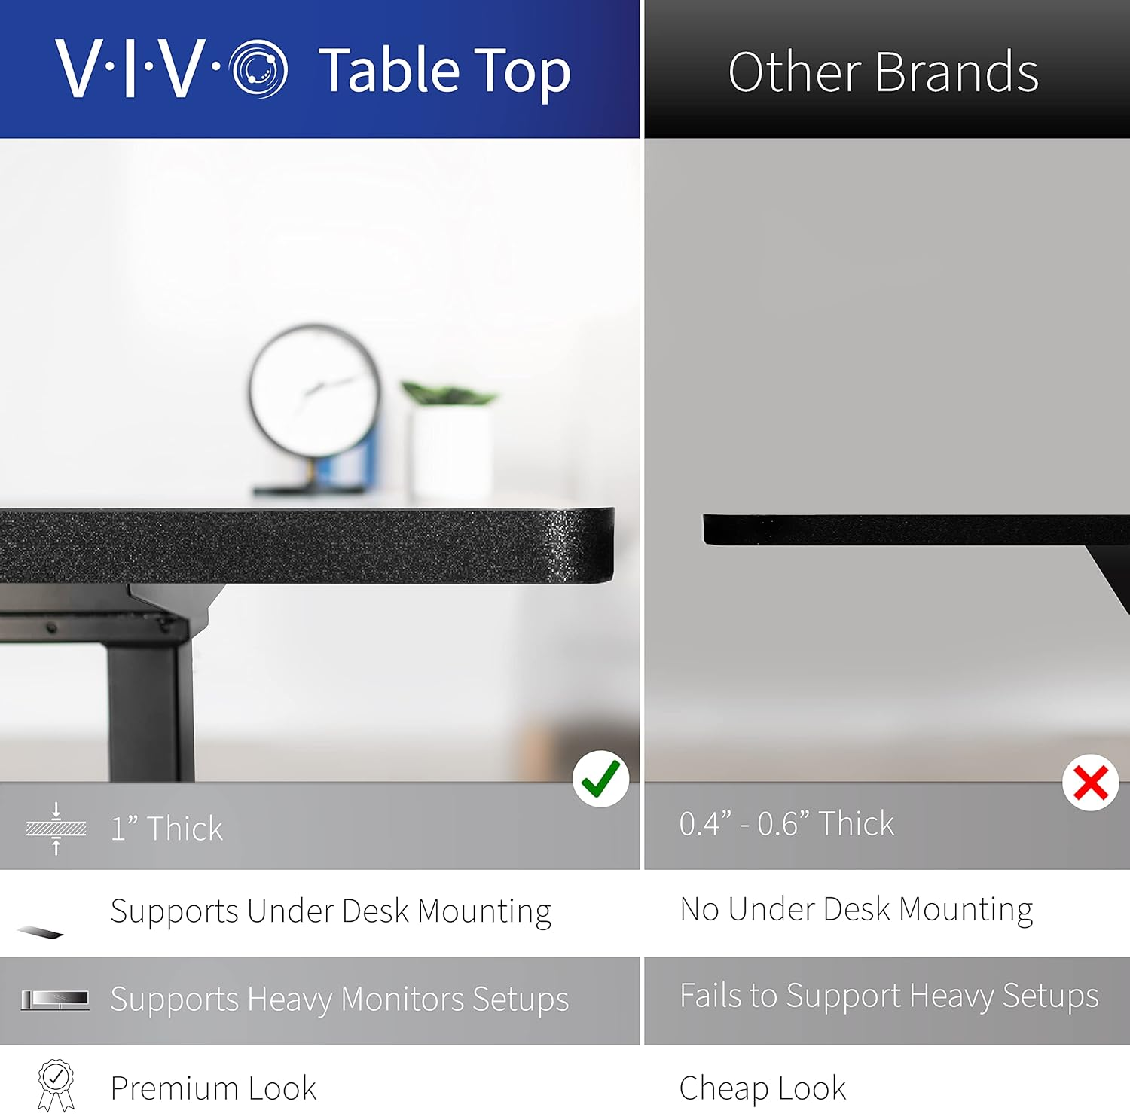

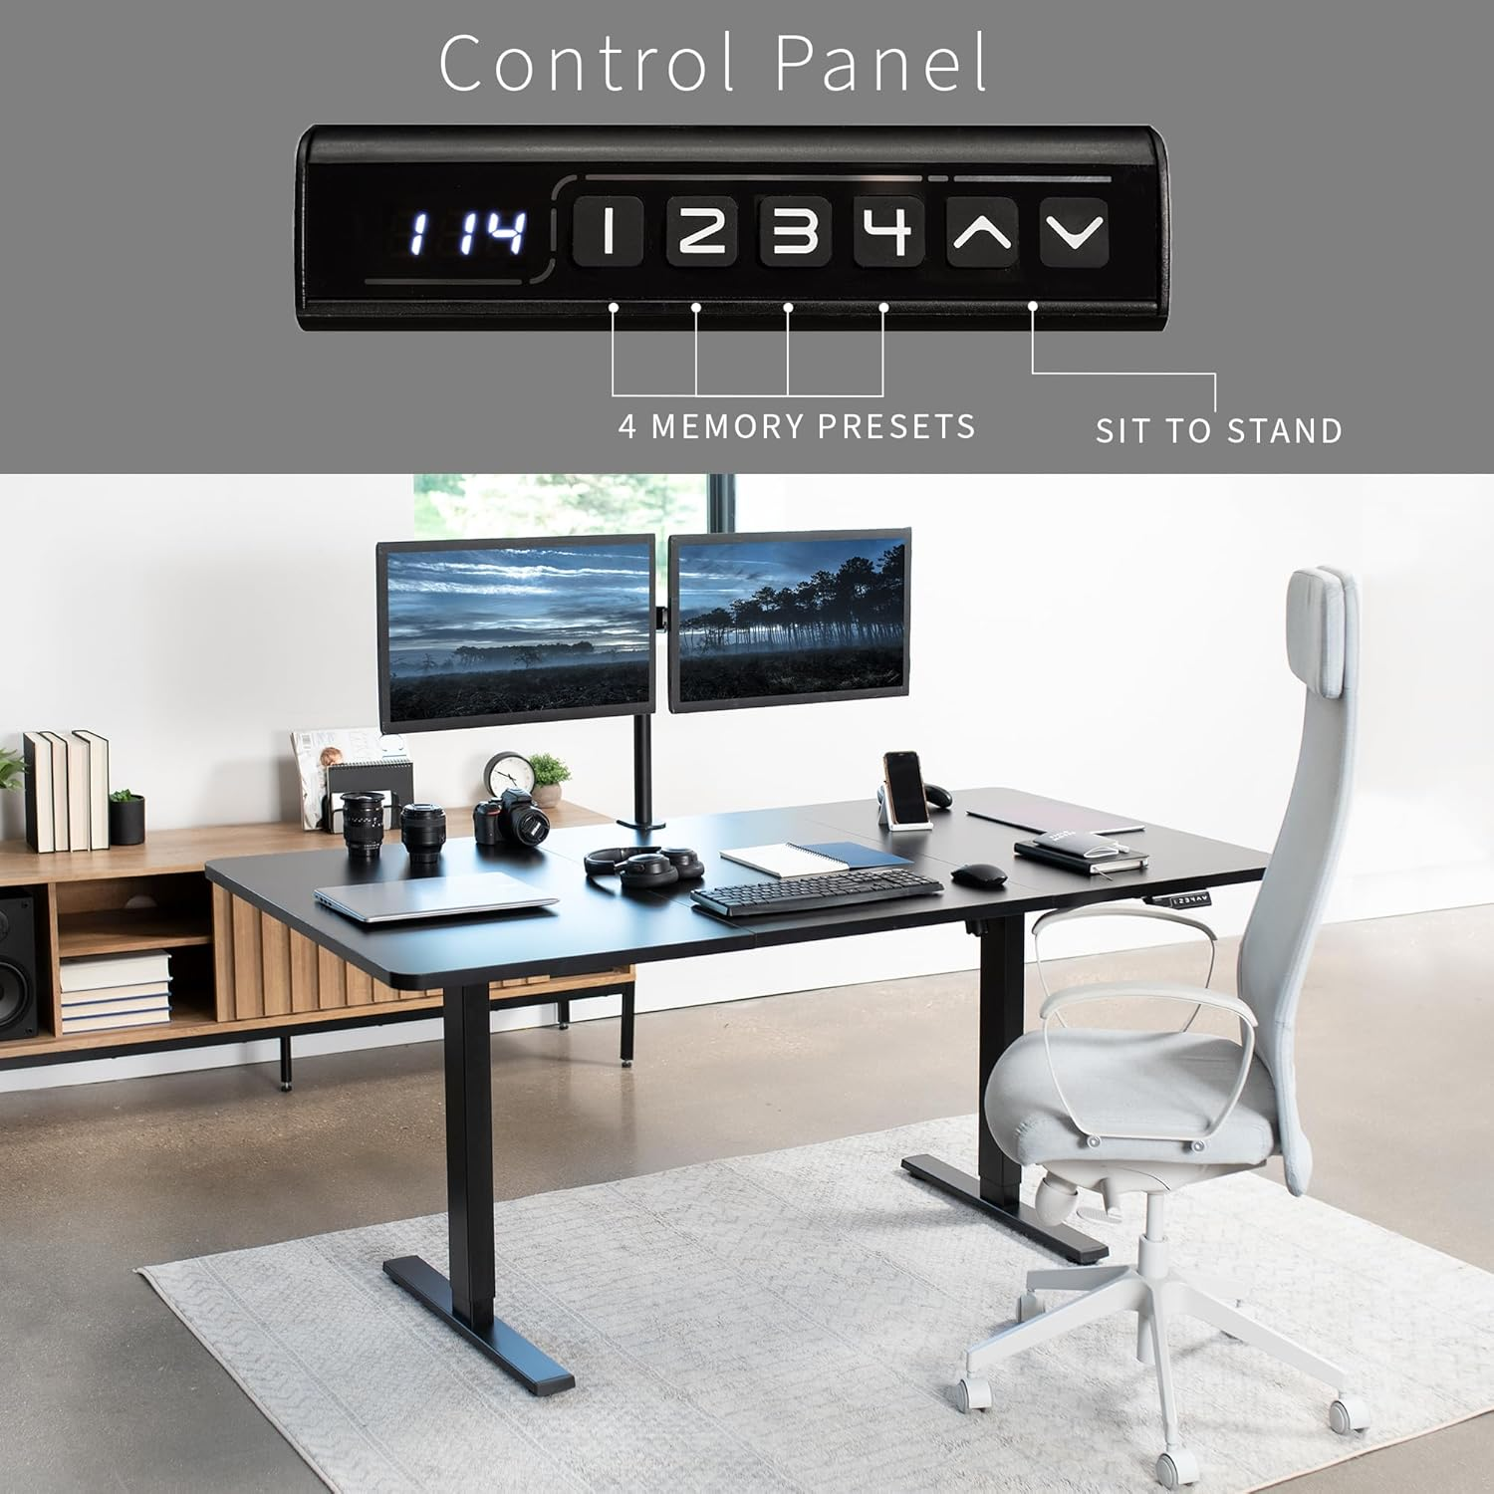

Approximaley 400 USD