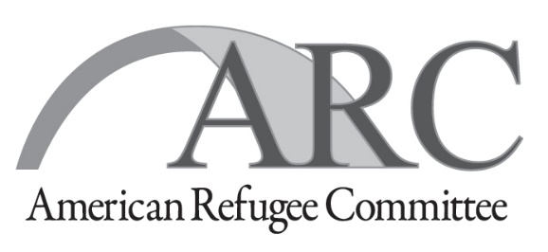
TENDER NOTICE
REFERENCE NO: ARC/RSS/ITT/2019/01
Date of Tender Publication: September 04, 2019

TENDER FOR DRILLING OF A BORE-HOLE IN KORIJO, LIWOLO KAJO-KEJI COUNTY
American Refugee Committee (ARC International) invites tender from qualified, registered drilling companies for drilling of bore-hole with approximate depth of between 95-110 meters as described and summarized in accordance with procedures, conditions and contract terms, as prescribed in the tender documents and on the Scope of Work that is part of the tender documents.
Qualifying and Conditions: The main criteria for admission to the tender process are as follows:
- Certificate of Registration with the relevant Government certifying Authority.
- Good track-record and references from previous clients (similar tasks) with telephone contacts of at least three referees.
- Sound financial & Technical capacity to undertake above works.
- Submission of the latest 3 months certified bank statement of the applying entity
Detailed instruction and tender Response documents will be available free by request through email at Procurement.juba@arcrelieg.org or may collect from ARC Office, Goshen House 2nd Floor, Ministries Road, Kololo, Juba. When requesting for Bid documents using email, please refer to Tender Reference Number (ARC/RSS/ITT/2019/01) and provide detail of your company name, contact person and contact numbers.
LAST DATE FOR BID COLLECTION: SEPTEMBER 23, 2019, 17 HRS
LAST DATE FOR BID SUBMISSION: SEPTEMMBER 24, 2019, 16 HRS

All submission need to be in ARC tender form submitted in sealed envelopes, Completed bids must be delivered by hand to the TENDER BOX in ARC office located in Goshen House 2nd Floor. Detail information is provided in tender instruction documents. Late submissions will NOT be accepted.
American Refugee Committee reserves the right to accept or reject any bid either fully or partially without assigning any reason whatsoever.

Operations Department
American Refugee Committee International, South Sudan Program
E: Procurement.juba@arcrelief.org , Phone: +211 921 498 128, +211 924 524 356

