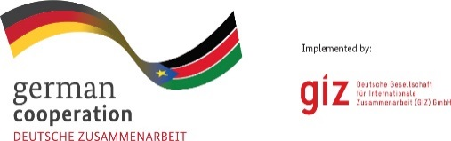
Date: 14th July 2020

Invitation to Tender
The Deutsche Gesellschaft fuer Internationale Zusammenarbeit (GIZ) GmbH – German Agency for International Cooperation – is owned by the Federal Republic of Germany and operates internationally. It implements commissions for the German federal government and other national and international, public and private-sector clients. Its development policy mandate is to help improving the standard of living and future prospects of people in partner countries all over the world, whilst stabilizing the natural resource base on which life depends.
The program ‘Strengthening resilience through capacity building for a pro-poor water supply in Gumbo, South Sudan’ is seeking an individual consultant for the position of an Institutional Development Advisor for the Water Sector. The assignment shall be for up to 125 days within the period from August 2020 to January 2021.
Applicants will receive the full ToR at their e-mail address if they have (a) proven expertise as water sector professionals with at least a postgraduate qualification in a relevant field, such as public health, business administration, or equivalent and (b) at least 5 years of professional international working experience in a similar position. The consultant must have proven his/her ability to work in complex and challenging environments and is highly familiar with the water sector in South Sudan. He/she should have an excellent command of spoken and written English in addition to at least one common language in South Sudan, such as Juba Arabic would be a valuable bonus.
Instructions:
- Interested applicants who meet above criteria (a) and (b) may send in their CV to procurement-ssd@giz.de until Friday, 24th July 2020 at 03:00 PM Juba local time. The subject line should state ‘Institutional Development Advisor for the Water Sector’. Later submission is not permitted.
- Upon evaluation of CV’s, GIZ shall send the complete ToR to prequalified applicants on 29th July 2020.
- Upon receipt of the ToR, a 3-page proposal and a financial offer shall be submitted in English language as hard copies in sealed envelopes (as described in the ToR) to the address below until Wednesday, 5th August 2020 at 3:00 PM Juba local time. Submission of the proposal and financial offer by e-mail is not permitted.

The successful bidder will be notified as soon as the evaluation is completed. However, if you do not hear from us until end of August 2020, you should consider your bid unsuccessful.
Please submit your documents to the attention of:
Procurement Department
GIZ Country Coordination office Juba
Ministries Road, Juba Town (Adjacent to Paradise Hotel Compound)
P.O.BOX 450
Juba, South Sudan

