[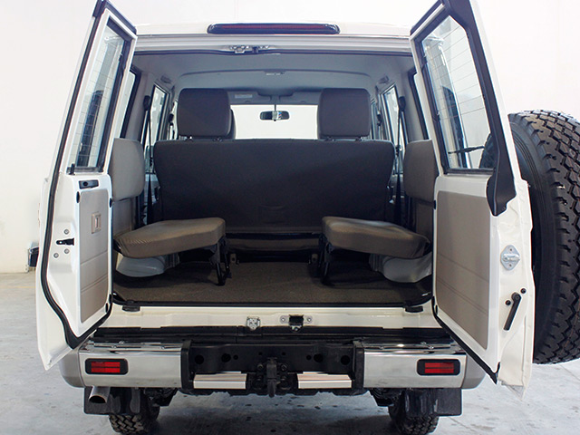](http://aboudcar.com/wp-content/uploads/2014/10/N4524%2008.jpg?92574)[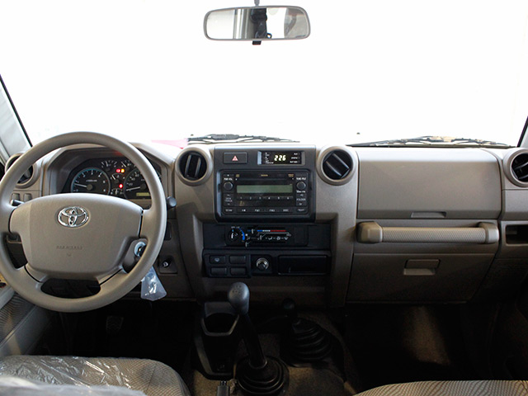](http://aboudcar.com/wp-content/uploads/2014/10/N4524%2007.jpg?67093)[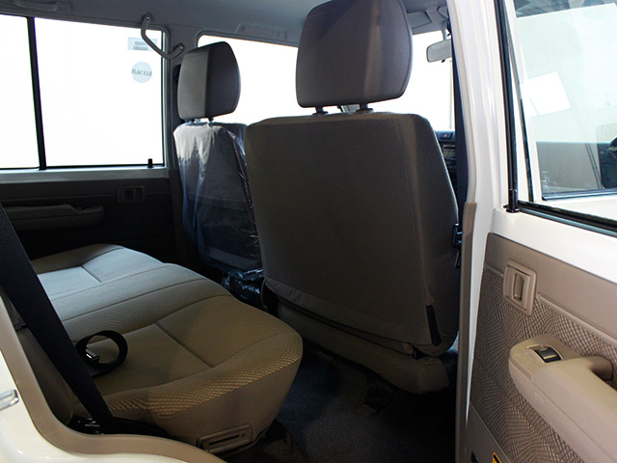](http://aboudcar.com/wp-content/uploads/2014/10/N4524%2006.jpg?67069)[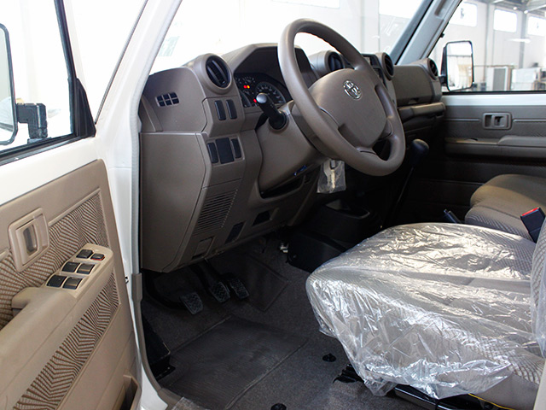](http://aboudcar.com/wp-content/uploads/2014/10/N4524%2004.jpg?92475)[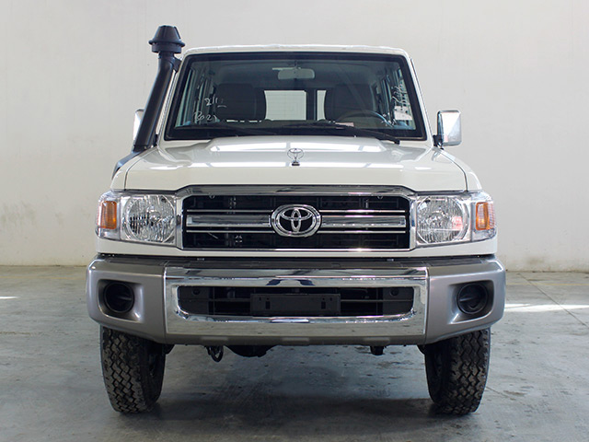](http://aboudcar.com/wp-content/uploads/2014/10/FLC25%2002.jpg?85185)[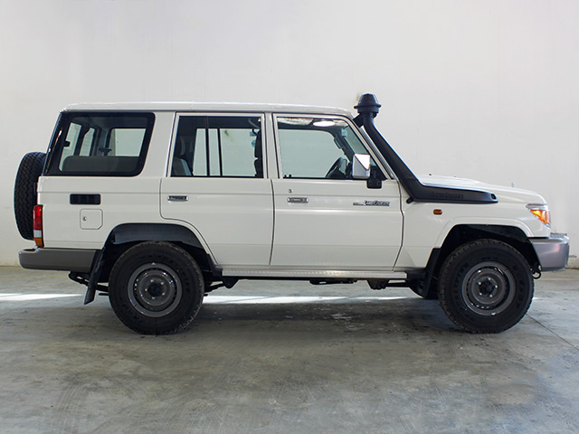](http://aboudcar.com/wp-content/uploads/2014/10/N4524%2001.jpg?99688)