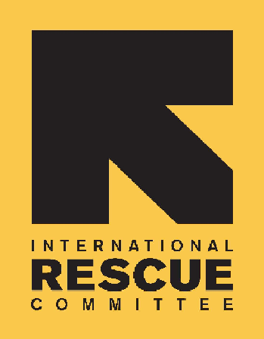
INTERNATIONAL RESCUE COMMITTEE, INC.

BID NOTICE

Founded in 1933, the International Rescue Committee is a global humanitarian leader that helps people whose lives and livelihoods are shattered by conflict and disaster to survive, recover, and gain control of their future.

The IRC has been operating in South Sudan since 1989. The IRC is registered and obtained Certificates of NGO operation from the Relief & Rehabilitation Commission (RRC) under serial No:020. The IRC is currently working in Rumbek, Ganyiel, Maban, Renk, Bentiu, Koch, AjoungThok, Malualkon, Panthou (Aweil South) and in Juba. The regular sectors in IRC South Sudan are Health, Nutrition, Child Protection, Women Protection & Empowerment, Governance, Protection Mainstreaming, Economic Recovery & Development.

The IRC is issuing Request for Proposals (RFPs) to solicit competitive sealed bids to establish a contract with a reputable company for the provision and supply of the following goods and services for IRC South Sudan.

No: | Description of goods/service required | Location/ Field Site | Category ID#
1 | Procurement of Toyota Land cruiser- 10-seater. | Jubal-South Sudan | IRC/WBC03/TOYOTA LC/2025

Interested and suitably qualified suppliers may download complete tender documents (RFP) from the IRC Website: http://www.rescue.org/about/procurement OR request them from ss-procurement@rescue.org during office hours.

Offers to the above-mentioned categories will not be accepted after cut-off time 1630hrs (South Sudan Local time) on the 5th of March 2025. Instructions on how to submit your proposals are provided in the tender documents.

Please quote the category I.D# as the subject of your Proposal.

