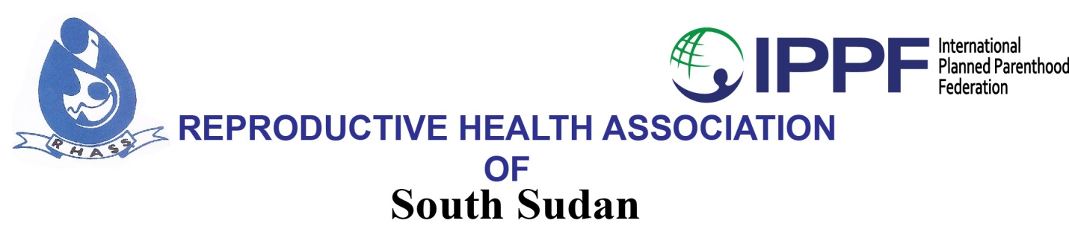

**TERMS OF REFERENCE (TOR)**

**Provision of Cash Transfer Services for RHASS in South Sudan**

**April 2025**

# BACKGROUND INFORMATION

Reproductive Health Association of South Sudan (RHASS) is currently implementing the Women Integrated Sexual Health (WISH2 DIVIDEND) Project in Central Equatoria, Western Bahr El Ghazal and Eastern Equatoria State. The project focuses on provision of Sexual and Reproductive Health to youths, men and women.

# Objective

The objective of this TOR is to select a qualified vendor to provide reliable, secure, and cost- effective cash transfer services that meet the RHASS's operational needs in South Sudan

# Scope of work

* 1. The agent delivers of funds to RHASS field offices within South Sudan as instructed by RHASS. Provide an accountability report to RHASS when such cash deliveries have been done;
  2. Comply with the turnaround times as will be agreed by the both parties;
  3. Ensure adequate liquidity at all times sufficient to meet RHASS’s cash demand;
  4. Take responsibility of all security and cash safety measures up to the cash delivery point;
  5. Notify RHASS in good reasonable time when the agent is not able to meet or deliver cash or is unable to implement RHASS’s instructions;
  6. Ensure compliance with all local and any international regulations required of Money transfer Agents in the Republic of South Sudan;
  7. Invoice RHASS for a refund of cash delivered or payments made on behalf of RHASS together with any commission as may be agreed by the both parties from time to time.

# Qualification of the agent

The agent should have the following qualifications and experience:

1. Must be legally registered and licensed to offer money transfer services within South Sudan.
2. At least three years’ relevant experience as a Cash transfer Agent in South Sudan;

# Roles of RHASS

1. Provide in writing a list of its authorized signatories mandated to issue instructions to the agent as well as the email address from which instructions will be issued and received
2. Issuance of clear cash delivery instructions or payment requests to the agent, duly signed by RHASS’s authorized representatives;
3. Provide the agent with the necessary documents that may be required from time to time to obtain the regulatory, security and safety approvals from the government and related entities.
4. Provide in writing a list of its authorized signatories mandated to issue instructions to the Agent as well as the email address from which instructions will be issued and received.
5. Make reimbursements together with the agreed commission to the Agent within the agreed credit period upon successful payment to the intended beneficiaries.
6. RHASS reserves the right to cancel, amend or re-advertise at any stage of the process

# Proposal submissions

Interested audit firms shall hand deliver financial proposals to RHASS Juba Office located at Star Village Building, First Floor,

Plot No: 187-188, Block iii

Gudele Road, Juba South Sudan by **18th April, 2025.**

OR

Proposal can also be sent to following e-mail address: [procurement@rhass.org.ss](mailto:procurement@rhass.org.ss) and cc [charles.oyet@rhass.org.ss](mailto:charles.oyet@rhass.org.ss), [langoya.martin@rhass.org.ss](mailto:langoya.martin@rhass.org.ss)