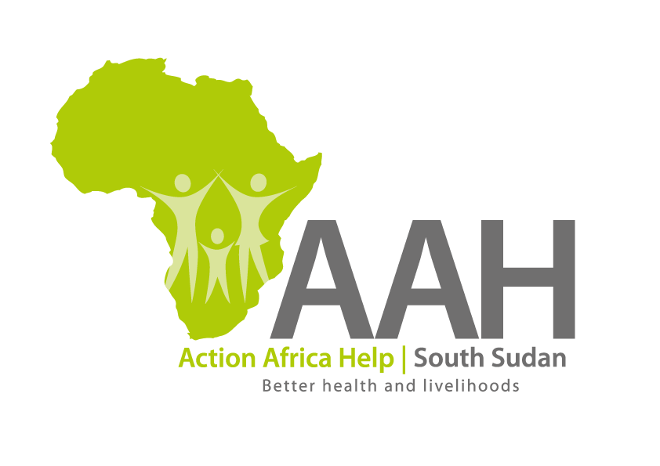
INVITATION TO BID

Background
Action Africa Help International (AAH-I) is a nongovernmental and nonprofit making Organization operating in South Sudan with a mission to support disadvantaged Communities to sustainably improve their standard of living through Community empowerment approach in partnership with stakeholders. AAH-I implements Primary Health Care, Agriculture, Humanitarian aid projects and Capacity Building.

The organization is inviting bids from reputable companies for various supplies and construction works.

NO | WORK DESCRIPTION
1 | Provision of labour for construction of 100 superstructure walls for PWSNS latrines in Pamir and Ajuong thok camps.
2 | Supply of assorted construction materials
3 | Supply of assorted vegetable seeds
4 | Supply of climate adoptive crop seeds
5 | Supply of Tata Truck tyres (11R22.5).

Interested bidders can collect detailed ITB and BOQ from AAHI/UNHCR Logistic base OR request through procurement.southsudan@actionafricahelp.org.

The deadline for the submission of the bids is 6th May, 2026.

