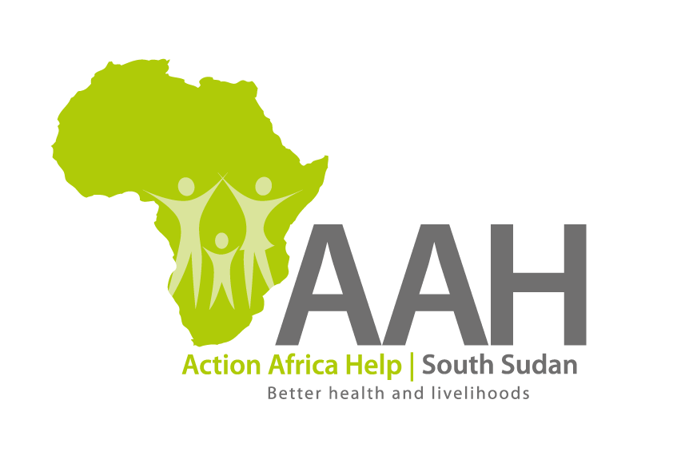
AAHI-South Sudan
Juba Office: Hai Gabat – Opp JIT Supermarket
Behind South Sudan Customs, Tel: +211 925 478 457
Email: ssudan@actionafricahelp.org
Website: www.actionafricahelp.org

INVITATION TO TENDER

Background
Action Africa Help International (AAH-I) is a nongovernmental and nonprofit making Organization operating in South Sudan with a mission to support disadvantaged Communities to sustainably improve their standard of living through Community empowerment approach in partnership with stakeholders. AAH-I implements Primary Health Care, Agriculture, Humanitarian aid projects and Capacity Building.

The organization is inviting bids from reputable companies for the Supply of fuel dispensing & pump station to our Renk Office and various caterpillar spare parts.

S/N | Name | Description | Quantity
1 | Fuel Dispensing & Pump Station | Gilbarco Veeder Root, one product, two hose model. | 1 pc
2 | Caterpillar | Assorted caterpillar spare parts

More details on the said tenders can be picked from AAHI/UNHCR Juba Logistics base during working hours (Monday to Friday, 9:00am to 11.30am and 2:00pm to 4.00pm)

Deadline for submission of the bids will be on 1st September, 2023 at 12:00pm.

