Malteser International
Country Coordination Office
Plot No: 445 Kololo Road 3k South
Tong Ping
Juba, South Sudan

3 September 2021

Request for Quotations for Agriculture Tools
RFQ-JUB-2021-0191

For delivery of agriculture tools to Malteser International warehouse on Bilpam Road in Juba

- Annex 1: Specification of Tendering
- Annex 2: Bill of Quantity

We look forward to receiving your tenders before the submission deadline on 10 September 2021 at or before 4:00 pm via E-mail to: mb.procurement-juba@malteser-international.org.

Please write in the Subject line of your email with tender: RFQ-JUB-2021-0191 for agriculture tools

Thank you for your cooperation.

Sincerely Yours,

South Sudan Coordination Office
Nermin Silajdzic. Country Logistics and Security Coordinator – South Sudan
Plot No. 445, Block 3, Kololo - US Embassy Road.
Central Equitorial State, Juba.
M: +211 (0) 911 746 963 · M: +211 (0) 924 767 949
nermin.silajdzic@malteser-international.org · Skype: nsilajdzic
www.malteser-international.org
Malteser International Europe/Malteser Hilfsdienst e. V., County Court Cologne, VR 4726
Executive Board: Karl Prinz zu Löwenstein, Dr. Elmar Pankau,
Douglas Graf Saurma-Jeltsch, Verena Hölken
Legal advice: This communication is for use by the intended recipient and contains information that may be privileged, confidential or copyrighted under applicable law. If you are not the intended recipient, you are hereby formally notified that any use, copying or distribution of this e-mail, in whole or in part, is strictly prohibited. Please notify the sender by return e-mail and delete this e-mail from your systems.

 please consider the environment before printing this email

1. SPECIFICATION OF BIIDING

Related to our advertised Request for Quotations (RfQs) RFQ-JUB-2021-0191 for agriculture tools MI herewith calls for tenders for delivery of supply of agriculture tools to MI warehouse on Bilpam Road in Juba.
Under the following reference number:
Donor project numbers: 1345-JUB-2021

Description of the organization and its activities
Malteser International, the worldwide relief agency of the Sovereign Order of Malta for humanitarian aid, has more than 50 years of experience in humanitarian relief and covers around 100 projects in some 20 countries in Africa, Asia and the Americas, annually. It provides aid in all parts of the world without distinction of religion, race or political persuasion. Christian values and the humanitarian principles of impartiality and independence are the foundation of its work.
In South Sudan, Malteser International operates in Juba, Yei, Wau, Maridi and Rumbek. In these locations, it’s activities include Health and Nutrition, Food Security and Livelihood, Water Sanitation and Hygiene and Health Programs
Objective of RfQ: In accordance with the overall targets of above-mentioned operations, MI plans to order agriculture tools with delivery to MI warehouse on Bilpam Road in Juba.
The technical specifications and conditions of the tendering process are described below in the Specification of Tendering and in the Annex 2: Bill of Quantity which are part of this RfQ.
Suppliers are invited to present tenders complying with the requirements here below specified.

Tenders Presentation
- The tender shall be via E-mail to: mb.procurement-juba@malteser-international.org.

The deadline for the delivery of the tenders is: 10 September 2021 at or before 4:00pm
- The tender shall be written in English
- The tender should be valid for 30 days after the deadline
- The format BoQ can be used or a separate one depending on supplier’s choice.

General conditions
- The tender shall be typed or written and signed on each page by the legal representative of the supplier,
- The winning supplier might be requested to provide catalogues, pictures, technical descriptions and/or samples of items at the order stage when required,
- The prices of the tender will be expressed in United States Dollars. The prices must be on unit price basis as well as by totals,
- The prices will be considered fixed. No additional change of whatsoever nature and type will be accepted by Malteser International,
- Malteser International reserves the right to accept or reject all tenders depending on prevailing condition at the time.

Technical specification
No. | Description | Unit | Quantity | Quality
1 | Steel Handle Hand Shovel | Pc | 1,150 | Good
2 | Hoe (Cock brand / metallic stamp and wooden handle) | Pc | 2,060 | Good
3 | Fork Hoe (big size – wooden handle) | Pc | 1,150 | Good
4 | Tines Rail Steel Garden Hoe | Pc | 1,060 | Good
5 | Slasher (plastic black hand handle) | Pc | 2,150 | Good
6 | Wheelbarrow (Alliance brand) | Pc | 138 | Good

Suggested agriculture tools by the farmers.
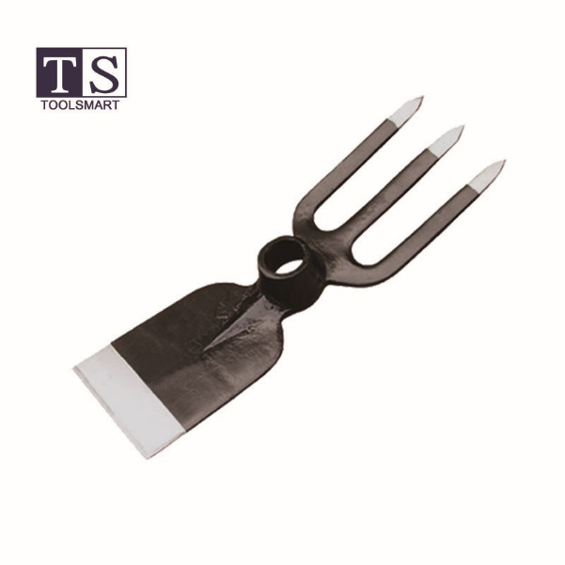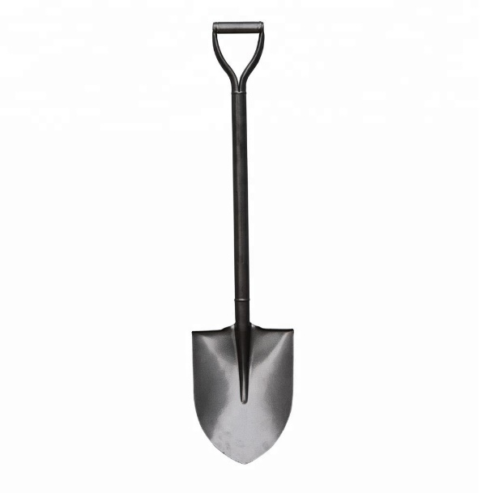
3 Tines Rail Steel Garden Hoe. Steel Handle Hand Shovel
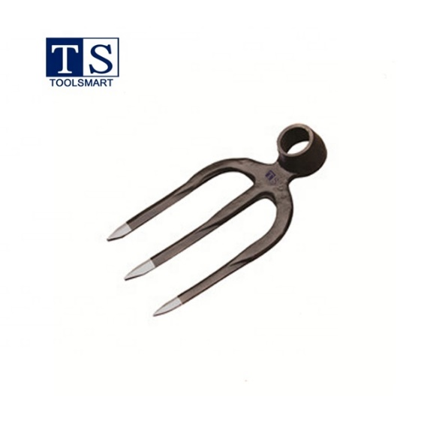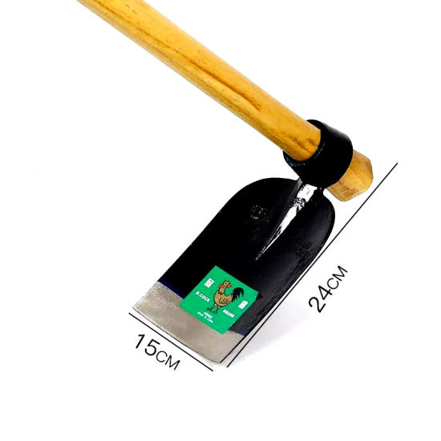
Fork Hoe. Hoe
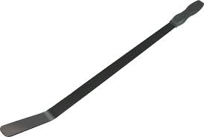
Grass slasher / Plastic black handle.

Timetable
Activities | DATE | TIME*
Deadline for submission of tenders | 10 September 2021 | 04:00 pm
Opening of submitted tenders | 13 September 2021 | -
Notification of award to the successful contractor | 20 September 2021 | -
Signature of contract agreement | 22 September 2021 | -
* All times are local time in Juba, South Sudan

Validity of tenders
Each company is bound to the tender submitted for a period of 30 days from the deadline for submission of tenders.

Language of tender
All tenders, official correspondence between companies and MI, as well as all documents associated with the tender request will be in English.

Submission of tender

Each tender shall be submitted via E-mail to: mb.procurement-juba@malteser-international.org on 10 September 2021, at or before 04:00 pm (local Juba time).

Content of tender
All submitted tenders must conform to the requirements mentioned in the RFQ. Furthermore, they must include the following documents:
Part 1 - Tender: A tender for the bided supply of agriculture tools to MI warehouse on Bilpam Road in Juba. The format BoQ can be used or a separate one depending on supplier’s choice. Additional sheets may be attached for further details.
Part 2 - Legal documents
- Copy of the company’s certificate of incorporation,
- Copy of Chamber of Commerce registration,
- Copy Tax Identification Certificate,
- Copy of Certificate of Operation,
- Company’s Bank Statement of last three months,
- Company’s official address,
- Bank account details (where money would be paid),

Ownership of tenders
MI reserves/funds ownership of all tenders received. As a consequence, bidders will not be able to stipulate requirements that their tenders are to be returned.
- Opening of submitted tenders
The tenders will be opened on 13 September 2021 in MI Country Coordination Office in Juba, South Sudan, by the Evaluation committee. The selection process will be recorded in writing by the committee.

Tenders’ evaluation
The criteria applied for the evaluation will be the legal conformity, the price, the technical experiences, the compliance with technical specifications and quality standards, and the capacity to deliver, delivery time and meet timeframes as specified. The work will be awarded to the winning bidder according to the timetable mentioned above.
- Specific Technical and Financial Evaluation Criteria to standards:
- Comparative Bid Analysis and justification basing on responsiveness of the selected supplier by evaluation committee
- Contract agreement will directly be issued to the selected supplier upon approval.
- Terms of payment
The payment will be done in United States Dollar by bank transfer or cheque as specified below:
- Payment terms will be within 10 business days after receipt of goods and invoice, by electronic bank transfer.

Annex 2: Bill of Quantity
The quantities stated against each item of the Bill of Quantities (BOQ) are the estimated quantities and are therefore provisional. The contractor shall be paid for actual quantities

No. | Description | Unit | Quantity | Unit Price USD | Total USD
1 | Steel Handle Hand Shovel | Pc | 1,150 | Good
2 | Hoe (Cock brand / metallic stamp and wooden handle) | Pc | 2,060 | Good
3 | Fork Hoe (big size – wooden handle) | Pc | 1,150 | Good
4 | Tines Rail Steel Garden Hoe | Pc | 1,060 | Good
5 | Slasher (black plastic hand handle) | Pc | 2,150 | Good
6 | Wheelbarrow (Alliance brand) | Pc | 138 | Good
 |  |  |  | Total

On behalf of Malteser International: 3 September 2021

Sincerely,

South Sudan Coordination Office
Nermin Silajdzic. Country Logistics & Security Coordinator – South Sudan
Plot No. 445, Block 3, Kololo - US Embassy Road.
Central Equitorial State, Juba.
M: +211 (0) 911 746 963 · M: +211 (0) 924 767 949
nermin.silajdzic@malteser-international.org · Skype: nsilajdzic
www.malteser-international.org
Malteser International Europe/Malteser Hilfsdienst e. V., County Court Cologne, VR 4726
Executive Board: Karl Prinz zu Löwenstein, Dr. Elmar Pankau,
Douglas Graf Saurma-Jeltsch, Verena Hölken
Legal advice: This communication is for use by the intended recipient and contains information that may be privileged, confidential or copyrighted under applicable law. If you are not the intended recipient, you are hereby formally notified that any use, copying or distribution of this e-mail, in whole or in part, is strictly prohibited. Please notify the sender by return e-mail and delete this e-mail from your systems.
 please consider the environment before printing this email

