# Appendix 3– Technical specifications

# 1. Background

GOAL is an international humanitarian organization working with the most vulnerable communities to help them respond to, and recover from, humanitarian crises and to assist them to build long term solutions to mitigate poverty and vulnerability. GOAL has been working in South Sudan since 1985 with a focus on health, nutrition, WASH, food security and livelihoods and is registered with Relief & Rehabilitation Commission (Registration #67). GOAL is implementing programs in Ulang, Manyo, and Renk in Upper Nile State, Twic, Gogrial East and Gogrial West in Warrap State, Abyei Special Administrative Area, Rubkona in Unit State and Kajo Keji in Central Equatoria State.

GOAL South Sudan is planning to contract a reputable boat company to supply one boat for its operations in Manyo county, Upper Niles State under the project “*Provision of Life-saving integrated Health, Nutrition, WASH and Protection-mainstreaming Interventions for Sudan Crisis Affected Populations in Renk and Manyo counties, South Sudan”*.

# Technical Specifications

The boat will be of description / specifications as follows:

Boat of W23S body made of fibred glass and Aluminum, with Sunshade framing with plastic canopy covering, with 4 benches, and loading capacity of 1000Kgs, 12 pax max, + Driver with 2-Stroke outboard engine 75HP (With 3-cylinder engine type,3-carburator fuel induction system, tiller handle steering, pre-mixing lubrication, manual starter system, CDI ignition system, Fuel tanker minimum 25litr size, fuel line, manual, engine hour-meter PET-3200R).

The breakdown of the specification requirement is as follows:

|  |  |  |  |
| --- | --- | --- | --- |
| **Number** | **Description of requirement** | **Unit** | **Qty** |
| 1 | **Boat** with W23S body made of fibred glass and Aluminum, with Sunshades framing with plastic canopy covering, 4 benches,  Loading capacity 1000Kgs, 12 pax max, + Driver | Piece | 1 |
| 2 | **2-Stroke Outboard Engine 75HP** (With 3-cylinder engine type,3-carburator fuel induction system, tiller handle steering, pre-mixing lubrication, manual starter system, CDI ignition system, Fuel tanker minimum 25litr size, fuel line, manual, engine hour-meter PET-3200R). | Piece | 1 |
| 3 | Anchor Complete 8kgs | Piece | 2 |
| 4 | Vest - buoyancy aid (Life Jacket) Green colour | Piece | 20 |
| 5 | Life Rings 30" x 2.5kg | Piece | 2 |
| 6 | Fire Extinguisher 1kg Dry Powder | Piece | 2 |
| 7 | First Aid Kit Medium | Piece | 2 |
| 8 | Fire Blanket 4'X4' | Piece | 2 |
| 9 | Paddle aluminium handle, blade & cap | Piece | 4 |
| 10 | Spare part for one-year standard operations: Fuel filter Assy-4 pieces, Water separator- 3 pieces, 200 litres of Outboard 2 stroke motor oil, 15 litres of Motor Gear Oil API-4SAE90, Spark Plug B8HS-10-3 pieces, Gasket washer – 2 pieces, Whistles – 2 pieces and propellers 2 pieces. | Item | 1 |

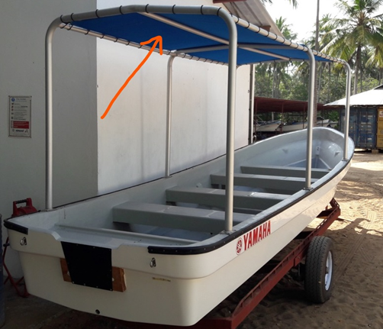

# Essential Criteria

* Valid Certificate of Incorporation
* Valid Tax Clearance Certificate
* Proof of boat Origin (Catalogue)
* Proof of dealer license for trading
* Must be able to deliver to South Sudan (Incoterm DAP 2020)
* Boat and engine must be brand-new (Manufacturer’s catalogue. Certificate of Origin

# Criteria Award

* Price 80%
* Quality 10%
* Delivery 10%

|  |  |
| --- | --- |
| **Criteria** | **Score** |
| **1.Quality/ Technical**   * Conformance to the technical specification * The dealer must have at least Five (5) years’ experience in the business as authorized dealer of brand-new boats. * The dealer must provide at least three (3) service contracts/purchase order/recommendation letters from previous clients for similar services. * Proof of authorization by original equipment manufacturer (OEM). * Provision of after sale services/ support. * Minimum 12 months’ full warranty. | 10% |
| **2.Delivery Lead time**  The bidder shall indicate the maximum lead time for delivering the boat to GOAL Juba office in South Sudan (DAP) | 10% |
| **3.Price** | 80% |
| **Total** | **100%** |

# 5. Service Requirements.

* Boat meets the specifications
* Boat available and delivery in a maximum of one (1) month.
* Brand new boat, W23S body, of Model 2024 or later with the requested accessories.

# 6. Delivery Terms

The delivery period of the above item shall be within thirty (30) calendar days upon receipt of the approved purchase order and the delivery site shall be at the address below.

GOAL Juba office in South Sudan

# 7. Payment Term

The payment shall be made within thirty (30) calendar days after complete delivery and written acceptance of deliverables by GOAL

|  |  |  |  |
| --- | --- | --- | --- |
| Signed: |  | | |
| Print name: |  | Position: |  |
| Company Name: |  | Date: |  |
| Address: |  | | |

# 