



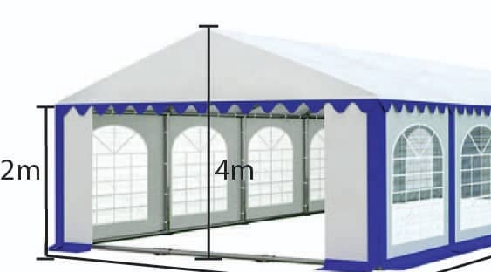

Height measurement

Canvas tent brand