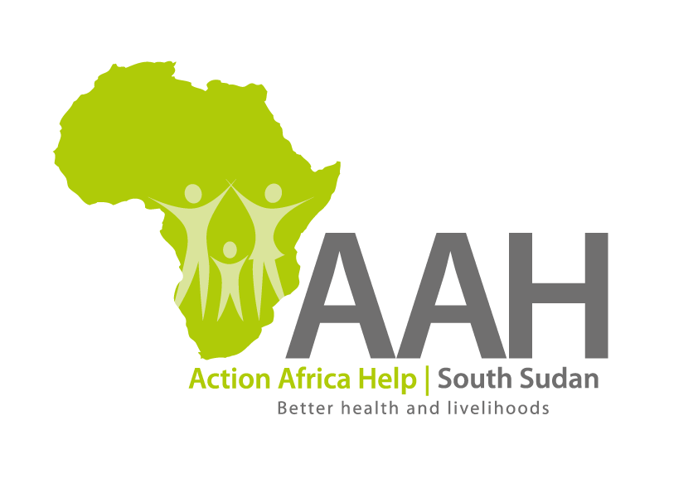
AAHI-South Sudan
Juba Office: Hai Gabat – Opp JIT Supermarket
Behind South Sudan Customs, Tel: +211 925 478 457
Email: ssudan@actionafricahelp.org
Website: www.actionafricahelp.org

INVITATION TO TENDER

Background
Action Africa Help International (AAH-I) is a nongovernmental and nonprofit making Organization operating in South Sudan with a mission to support disadvantaged Communities to sustainably improve their standard of living through Community empowerment approach in partnership with stakeholders. AAH-I implements Primary Health Care, Agriculture, Humanitarian aid projects and Capacity Building.

The organization is calling for quotations from reputable companies for supply of the following materials to Maban.

No | DESCRIPTION | UNIT | QUANTITY
1 | Cement | bags | 85
2 | Formwork timber (10x1) | pcs | 35
3 | Timber (4x2) | Pcs | 5
4 | Aggregates (16ton dump truck lorry | Trip | 5
5 | Sand (16ton dump truck lorry) | Trip | 5

The deadline for submission should be on 2nd May, 2022

Other details for the tender should be picked from AAHI/UNHCR Logistic base OR
AAHI Office in Maban

