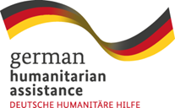
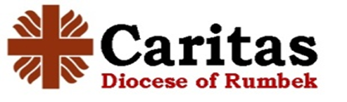

27th September 2023
INVITATION TO TENDER

Tender reference No: 5963/08/23/GFFO – CDOR – WASH

TENDER FOR: “WASH – REHABILITATION OF STRATEGIC BOREHOLES”

With financial support of the German Federal Foreign Office (GFFO), Caritas Diocese of Rumbek (CDOR) invites sealed or encrypted tenders from eligible candidates for the “WASH- REHABILITATION OF STRATEGIC BOREHOLES” in Rumbek Centre County (Matangai, Malek & Mayom Payams), and Tonj North County (Awul & Man-aloor Payams) whose specifications are detailed in the Tender Document. To obtain tender specifications (contact: operations@dioceseofrumbek.org)

Interested eligible candidates are advised to find details attached together with this advert. Any further information can be addressed to email address: dengmalek@caritasdor.org operations@dioceseofrumbek.org, pastoral@dioceseofrumbek.org

Any queries will be responded to before the close of the biding time period.

BIDS must be provided and submitted as a softcopy in encrypted non editable form and sent to operations@dioceseofrumbek.org:

Tender for the WASH – REHABILITATION OF STRATEGIC BOREHOLES – CDOR

Open only at Tender opening

Please Quote file Reference as below;

#: TENDER NO: 5963/08/23/GFFO – CDOR – WASH

Potential bidders are advised to submit their respective bids not later than Friday, the 6th day of October 2023 at 1600Hrs Centra African Time

Tender documents will be opened by the tender committee at Pandor Guest house, Rumbek on 9th October 2023. The bidders should share the password on 9th October 2023 to enable access to the document. Bidders will not be admitted at the tender opening.

