INVITATION TO TENDER – CONSTRUCTION SERVICES
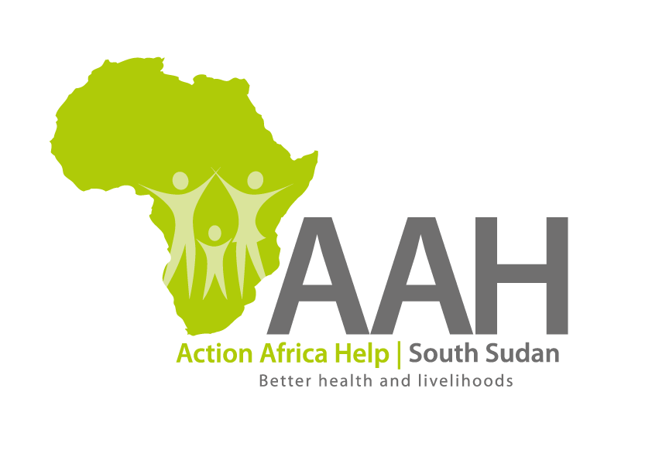
Background
Action Africa Help International (AAH-I) is a nongovernmental Organization and nonprofit making operating in South Sudan with a mission to support disadvantaged Communities to sustainably improve their standard of living through Community empowerment approach in partnership with stake holders. AAH-I implements Primary Health Care, Agriculture, Humanitarian aid projects and Capacity Building.

The organization is inviting bids from competent and reputable construction companies for the following construction services.

 | Description | Remarks
 | Provision of labour and materials for renovation of WAU MDT Buildings | BOQ to be picked from AAHI Juba Office and Wau Logistic base.

More details on the said tender can be picked from AAHI/UNHCR Juba Logistics base during working hours (Monday to Friday, 9:00am to 11.30am and 2:00pm to 4.00pm) also Wau office.

Deadline for submission of the bids will be on 11th December, 2023 at 12:00pm.

