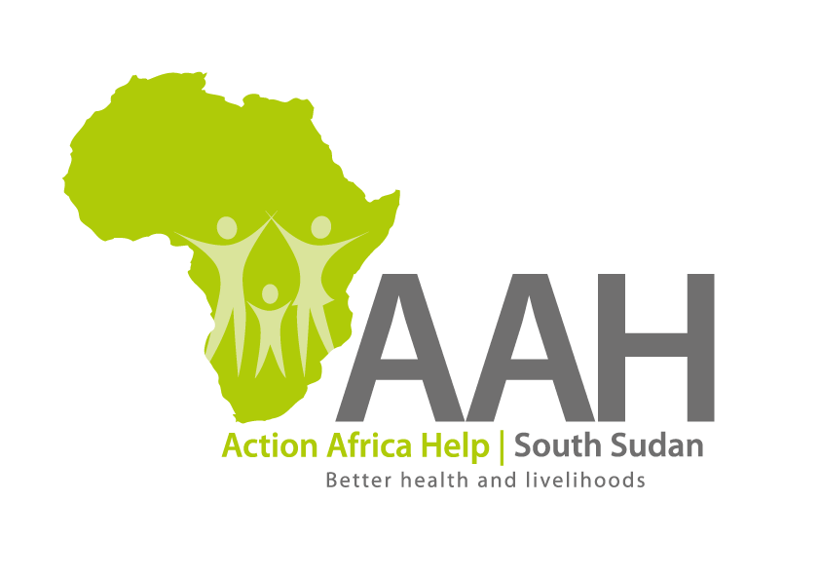
AAH-I South Sudan
Juba Office, off Munuki Road,
Next to South Sudan Civil Service Commission

INVITATION FOR TENDER

Background
Action Africa Help International (AAH-I) is a nongovernmental and nonprofit making Organization operating in South Sudan with a mission to support disadvantaged Communities to sustainably improve their standard of living through Community empowerment approach in partnership with stakeholders. AAH-I implements Primary Health Care, Agriculture, Humanitarian aid projects and Capacity Building.

The organization is inviting quotations from reputable companies for provision of the following construction services in Jamjang.

No | Description | Comment
1 | Provision of labour for maintenance of classrooms of five schools in Ajuong Thok | BOQ to be picked from AAHI Juba Logistics Base or AAHI Jamjang Logistics base.
2 | Provision of labour for maintenance of classrooms of four schools in Pamir | BOQ to be picked from AAHI Juba Logistics Base or AAHI Jamjang Logistics base.

Detailed ITB to be picked from AAHI/UNHCR Juba Logistic base/Jamjang Logistics Office during working hours.

Deadline for submission of the bids will be on 25th April, 2024 at 12:00pm.

