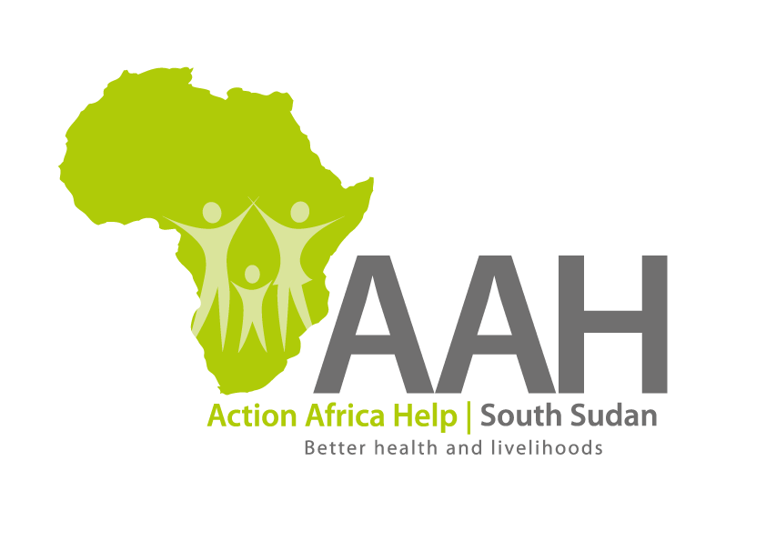AAH South Sudan

Juba Office: **Hai Gabat – Opp JIT Supermarket**

**Behind South Sudan Customs, Tel: +211 925 478 457**

**Email:** [**ssudan@actionafricahelp.org**](mailto:ssudan@actionafricahelp.org)

**Website:** [**www.actionafricahelp.org**](http://www.actionafricahelp.org)

|  |
| --- |
| **INVITATION TO TENDER** |

**Background**

Action Africa Help International (AAH-I) is a nongovernmental and nonprofit making Organization operating in South Sudan with a mission to support disadvantaged Communities to sustainably improve their standard of living through Community empowerment approach in partnership with stakeholders. AAH-I implements Primary Health Care, Agriculture, Humanitarian aid projects and Capacity Building.

The organization is inviting quotations from reputable companies for provision of labour and materials for the following activities in Renk.

|  |  |  |
| --- | --- | --- |
| **NO** | **DESCRIPTION** | **comment** |
| 1 | Supply of marram, grading and gravelling of access road leading to warehouse in Renk | BOQ to be picked from AAHI Juba Logistics Base |
| 2 | Supply of marram, spreading, levelling and compaction of warehouse compound in Renk | BOQ to be picked from AAHI Juba Logistics Base |

Detailed ITB to be picked from AAHI/UNHCR Juba Logistic base during working hours.

Deadline for submission of the bids will be on **8th November, 2024** at **12:00pm.**