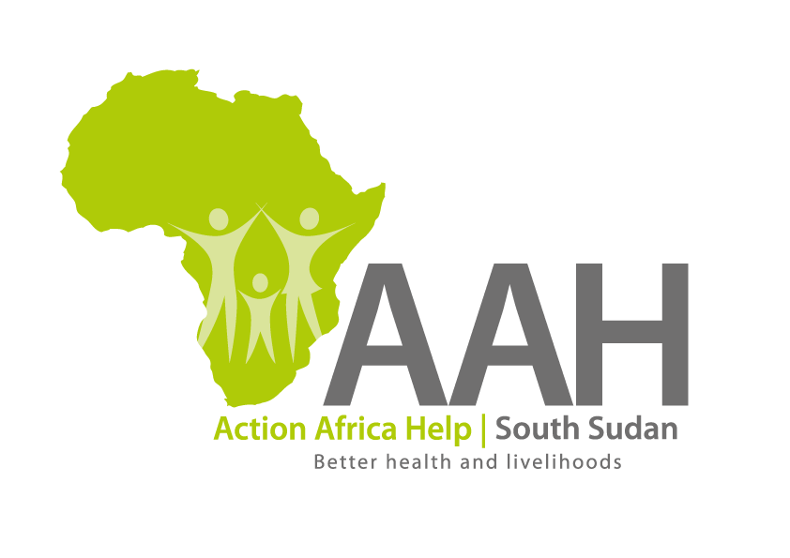
INVITATION TO BID

Background
Action Africa Help International (AAH-I) is a nongovernmental and nonprofit making Organization operating in South Sudan with a mission to support disadvantaged Communities to sustainably improve their standard of living through Community empowerment approach in partnership with stakeholders. AAH-I implements Primary Health Care, Agriculture, Humanitarian aid projects and Capacity Building.

The organization is inviting bids from reputable companies for supply of the grain grinding machine.

NO | WORK DESCRIPTION
1 | Supply of 3 complete sets of 10HP lister diesel engine grain grinding mills.

Interested bidders can collect detailed ITB and BOQ from AAHI/UNHCR Logistic base OR request through procurement.southsudan@actionafricahelp.org.

The deadline for the submission of the bids is 20th November, 2025.

