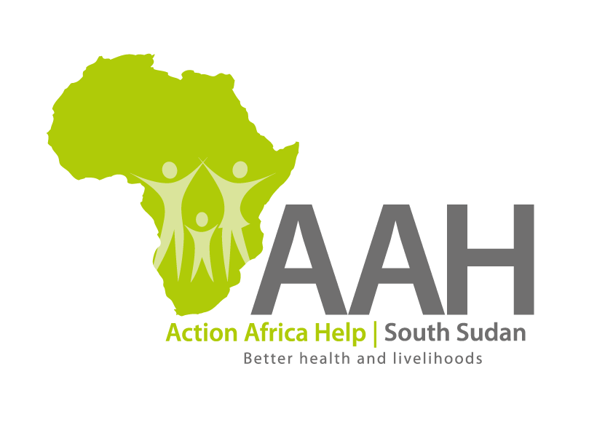
AAH-I South Sudan
Juba Office, off Munuki Road,
Next to South Sudan Civil Service Commission

Call for Pre-qualification of Suppliers and Service Providers for the year 2020
- Introduction

The Action Africa Help International (AAH-I) South Sudan is calling for applications for pre-qualification from competent and qualified suppliers and service providers for the provision of various categories of goods and services for the year 2020. The pre-qualification will be followed by a Request for Quotations (RFQ), Invitation to Bid (ITB) and/or Request for Proposal (RFP) which may result in Long Term Agreements with the successful bidders.

Companies that wish to participate in the process are required to complete the application forms indicating the categories for which the applications are being submitted.

More information on the requirements, List of categories and application form can be downloaded from AAHI Website and NGO Forum.

The deadline for receiving applications is 9th December 2019 at 1600hrs, East Africa Standard Time.

