INVITATION TO TENDER
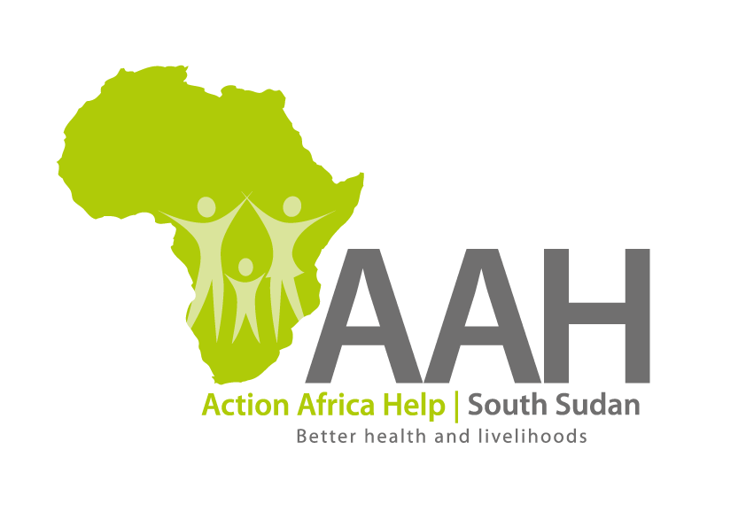
Background
Action Africa Help International (AAH-I) is a nongovernmental and nonprofit making Organization operating in South Sudan with a mission to support disadvantaged Communities to sustainably improve their standard of living through Community empowerment approach in partnership with stakeholders. AAH-I implements Primary Health Care, Agriculture, Humanitarian aid projects and Capacity Building.

The organization is inviting bids from reputable companies for provision of consultancy services as described below:

S/No: | Description
 | Computer literacy training of 2 Apex body members for 2 weeks on the following packages: Introduction to computer, Ms Word and Ms excel

More details on the said tenders can be picked from AAHI/UNHCR Juba Logistics base during working hours (Monday to Friday, 9:00am to 11.30am and 2:00pm to 4.00pm)

Deadline for submission of the bids will be on 13th December, 2023 at 12:00pm.

