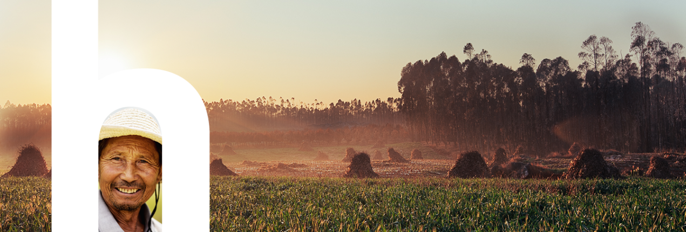

|  |
| --- |
| Dated 03 February 2020 |
| HUMANITARIAN LEADERSHIP ACADEMY |
| TERMS OF REFERENCE |

**TERMS OF REFERENCE**

**Title:** Impact stories from South Sudan – Supporting Effective Humanitarian Partnerships

**Duration of contract:** 3 months

**Budget:** The maximum budget is GBP 5,000 but cost will be a consideration in the selection of the successful bid.

**Location:** South Sudan. If the provider is based elsewhere they should demonstrate the ability to conduct some aspects of the project in South Sudan by travelling there or subcontracting local partners.

1. **Background and Context**

As the Grand Bargain highlights, humanitarian crises are becoming more frequent, complex and widespread than internationally led responses can cope with. Numerous studies since 2016 show that, in general, the Principles of Partnership are not applied meaningfully, influence of local actors in response strategy and decision-making is inadequate, and local capacity strengthening is on an ad hoc basis in the interests of the international partners.

The Humanitarian Leadership Academy (the Academy) and Save the Children are piloting a series of local humanitarian capacity strengthening initiatives to enable local actors in a variety of crisis prone countries to strengthen individual staff competencies through blended learning and organisational guidance.

These initiatives test locally-owned institutional learning with sector-wide applicability independent of the interests of international actors. In-country governance and delivery methods have been decided with local and national actors to enable ownership and sustainability, while global governance focuses on technical support, synthesis across contexts and dissemination of learning for improved humanitarian action and partnerships globally.

The Supporting Effective Humanitarian Partnerships (SEHP) project is the first of these initiatives, has been ongoing in South Sudan since April 2019 and involves 15 local and national organisations supported by an In-Country Project Coordinator (ICPC), with further support from the South Sudan NGO Network (SSNN).

The first phase of the project is due to come to a close in April 2020.

1. **Objectives of contract**

The Provider will support the Academy in developing a suite of informational, advocacy and marketing material that provides stories, lessons learned and implications for the localisation agenda[1] from the project,

This suite will consist of a series of videos (totalling 20 minutes, eg: 10 videos that are 2 minutes long or 5 videos that are 4 minutes long or some combination of the two) presenting testimonials from the participating organisations (based on the interviews with staff members) and other stakeholders, most of whom will be based in South Sudan. These would be edited to provide examples of how the project has impacted them in a punchy way that could be shared on social media or in conferences/events with international organisations.

The Provider will be responsible for:

- Providing a coherent narrative approach (based on input from the Academy) for the suite, by shaping the content and the medium to relay the desired message to an international audience.

- Capturing pictures and footage at events in South Sudan associated to the project, for use in the suite.

- Conducting filmed interviews with 15-25 selected individuals (project organisers, staff from participating organisations, other stakeholders, etc.) mostly based in South Sudan.

- Designing, producing and editing the videos.

1. **Resources and engagement from the Academy**

The Academy’s Digital Communications Adviser will direct the Provider in determining the strategic direction of the suite development as well as manage its delivery.

The Academy’s Organisational Solutions Adviser will be available to provide substantive input on approach, messaging and content and will act as a resource person on the SEHP Project.

The ICPC will be available on site in South Sudan to coordinate local media development with direct guidance from the Provider.

A series of interviews with participants, filmed using basic equipment (smartphones, point and shoot cameras, etc.) has already been recorded in July 2019 and will be shared with the successful applicant to provide an indication of the types of responses that can be expected from local stakeholders. Whether these interviews should be used in the final product depends solely on the Academy and the Provider should not factor them in as part of the raw footage when submitting an Expression of Interest.

1. **Proposed schedule and deliverables**

The target delivery date for the suite will be mid-May 2020.

The Provider should expect project kick-off as early as mid-February 2020 to develop a narrative approach and organise the gathering of raw media that would form the basis of the suite.

1. **Essential criteria**

The Provider should be able to showcase:

- Extensive work in producing informational, advocacy and marketing material, preferably for international humanitarian actors (examples of relevant past work both in print and visual media should be included in the Expression of Interest).

- Demonstrable experience working with local actors to provide content for international media.

- Demonstrable experience sourcing media from East Africa and, preferably, South Sudan.

1. **Submission**

Please use the attached form to submit an EOI



Submission deadline: **16 February 2020**

1. Please submit completed Expressions of Interest to Anne Garcon at [a.garcon@humanitarian.academy](mailto:a.garcon@humanitarian.academy)

1. For more about the localisation agenda: <https://interagencystandingcommittee.org/about-the-grand-bargain>