Terms of Reference (TOR) for rehabilitation of two boreholes with flood resilient platform in Fangak-County (Kuryang and Manajang).
Project: - JESI-Plus
Date: 26th November- 2025
Purpose: Rehabilitation of flood resilient platform of Boreholes in Fangak County (Kuryang and Manajang

Introduction

Project description
The JESI Plus Project, implemented by IMA World Health, is a comprehensive initiative aimed at improving health, nutrition, water, sanitation, hygiene (WASH) services in the counties of Pigi, Fangak, Nyirol, and Ayod in Jonglei State, South Sudan. The project run from May1th, 2024, to April 30th, 2026, focus on several key areas:
Health Services: Establishing mobile tent clinics to provide routine outpatient consultations, including essential medical supplies and consumables. The project also includes supportive supervision and training for county health department staff.
Nutrition: Screening and treating malnutrition, particularly among children under five and pregnant and lactating women. The project aims to ensure that these vulnerable groups receive appropriate nutritional support.
WASH: Improving access to clean water and sanitation facilities. This includes the rehabilitation of water points and the promotion of hygiene practices to prevent waterborne diseases
- Project Location: Fangak County (Kuryang and Manajang).

Objectives of the activities: -
Improving access to clean water, this includes the rehabilitation of water points with flood resilient platform in Fangak County and the promotion of hygiene practices to prevent waterborne diseases
Scope of work: -
- Re-tripping all the raiser main Pipes.
- Raising the flood resilient platform at the height of 1.5 meters.
- Metal fabrication for the flood resilient platform at the height of 1,500 mm x length 2,000 mm x width 1,500 mm.
- Casting the flood resilient platform, screeding and cowering for 7 days for the flood resilient platform concrete to dry.
- Welding the stair of the flood resilient platform and raff cast the foot stair to prevent from sliding.
- Rehabilitating the flood resilient platform at a distance of 6,000 mm long and rehabilitating sock pit for the animal’s depth of 1,000 mm x length 1,000 mm x width 1,000 mm (1,000 mm cub).
- Pump testing/flushing of the flood flood resilient boreholes well for at least 6 hours to remove all the sediment present in the well.
- Welding flood resilient rail to support people with disability like elderly people, people with disability, children and pregnant mothers.
- Designing and welding sign post on the borehole’s platform attached with the rail.
- Painting the signpost and IMA World Health will provide the wording to be printed.
- Checking the raiser main pipes for damages and cylinder for leakages.
- Dis-infection of the boreholes using 1% of chlorine solution of 65-70 grams.
- Reinstallation of the raiser main pipes and pump testing using 20-liter jerrycan and the stop watch.
- On-job mentorship of water management committees for a period of four days.
Result/Outcome:
- The community have sufficient access to safe, clean and potable drinking water.
Design Caption: -
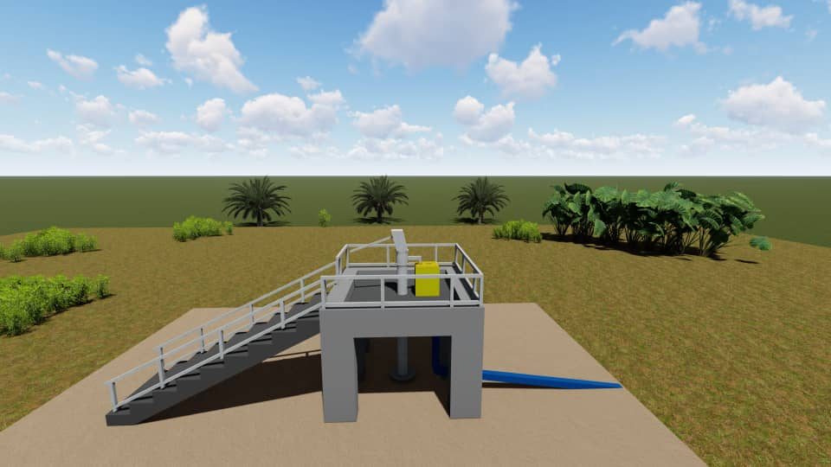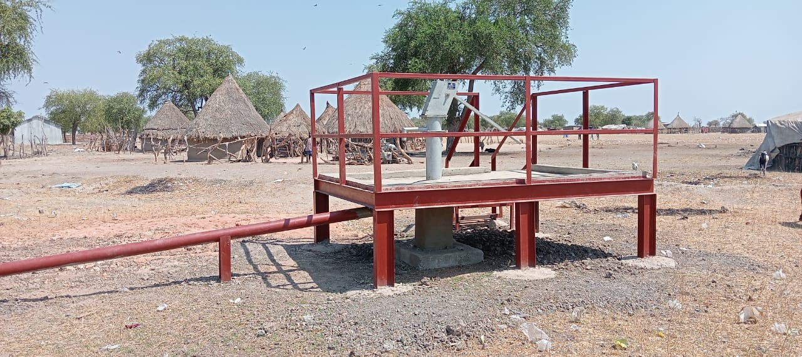
The rehabilitation work is going to be with metallic and concrete work and the measurement is on the attached document in PDF.
Prepare by: - Malesh Richard William……Sign: - …………………... Date: - 26th November/2025
Supervisor Approval: -.…………………... Sign: - …………

