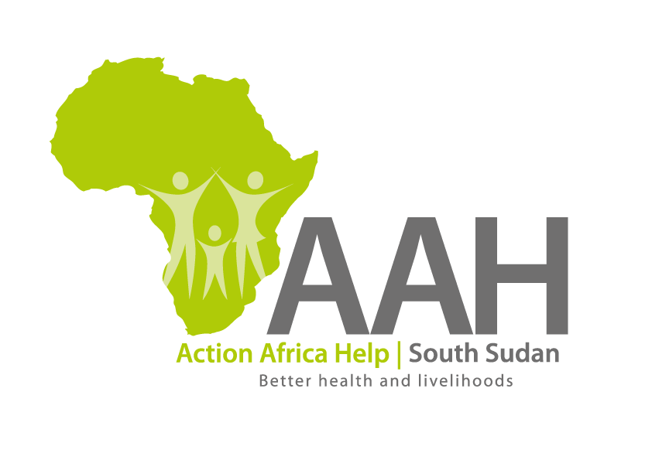
INVITATION TO BID

Background
Action Africa Help International (AAH-I) is a nongovernmental and nonprofit making Organization operating in South Sudan with a mission to support disadvantaged Communities to sustainably improve their standard of living through Community empowerment approach in partnership with stakeholders. AAH-I implements Primary Health Care, Agriculture, Humanitarian aid projects and Capacity Building.

The organization is inviting bids from reputable companies/individuals for provision of the following services:

NO | DESCRIPTION
1 | Microsoft Dynamics 365 Business Central Data Cleanup services. | TOR to be requested through the email indicated below.

Interested bidders can request the detailed ITB and TOR through procurement.southsudan@actionafricahelp.org.

The deadline for the submission of the bids is 12th May, 2026.

