REQUEST FOR QUOTES (RFQ)

RFQ #: | PRF NO: SRN-1-03492
Purpose: | Purchase of Big tents 4X12 Meters Branded with IMA Logo & US Flag for Nyambor HF (Nyirol County) & Wunbiem HF (AyoD County), Transportation and Installation
Issue Date: | 7th January 2026
Closing Date: | 12th January 2026
Questions Due: | 8th January 2026
Anticipated Award Date: | ^{13th January} 2026
Anticipated Award Type: | Contract service /PO
RFQ Contents and Attachments | - Introduction  - Requirements and Commodity Table  - Evaluation Criteria  - Terms and Conditions  - Bid Submission Instruction(s)  - Annexes  - Attachment A- Small Business Certification Form  - Attachment B- Bids Cover Sheet  - Attachment C- Past Performance Form  - Attachment D- NDAA Vendor Compliance Form

Corus Procurement Ethics

Corus International and its family of organizations are committed to a transparent and ethical procurement process aiming to achieve the best value for money, fairness, integrity, and doing business in compliance with the US government regulations, the beneficiaries, donors, and partners' interests.

Corus does not allow accepting any monetary transaction, gratuity, or compensation of any type from current or potential vendors or suppliers in exchange for or as a reward for a business. Therefore, all potential vendors and suppliers taking part in this solicitation must not offer fraud, bribery, or kickback to an employee or staff of Corus. Any vendor or supplier violating these standards will be automatically disqualified for doing business with Corus in the future.

A comprehensive list of Corus's ethical standards as well as information on how to report any violation pertaining to this solicitation (Corus's Integrity and Ethics Reporting Hotline) is found here: https://corusinternational.org/ethics-and-policies-corus-international.

- INTRODUCTION:

IMA World Health is a member of Corus International]. Corus International combines over 150 years of experience of our non-profit and for-profit subsidiary organizations – IMA World Health, Lutheran World Relief, CGA Technologies, Ground Up Investing, and Farmers Market Brands. Together, the organizations take a systematic approach to grow rural economies, eliminate extreme poverty, ensure access to quality healthcare, and respond to urgent humanitarian needs in fragile settings.

Corus leads an ensemble of social impact organizations working together in the world’s most fragile settings to deliver the holistic, lasting solutions needed to overcome the interconnected challenges of poverty, health care access and climate change. Corus is a new model in the international space, creating a consortium of specialized non-profit and for-profit entities for greater impact. Our annual budgets have ranged between $110-130 million a year. Additional growth is expected.

Further details about the organization can be found at: https://corusinternational.org

- REQUIREMENT AND COMMODITY TABLE:
IMA World Health invites qualified suppliers to submit offers in accordance with the requirements and specifications listed in this document. Quotes must be received by IMA World Health no later than 12th January 2026 before 2:00pm and see the details below.

S/N | Commodity Name and Description | Unit of Measure | Total Qty | Unit Price | Total Price
1 | Purchase of big tents 4X12 Meters, Branded with IMA logo and US Flag for Nyambor & Ayod Health Facilities | Pieces | 5
2 | Transportation and Installation ground surface will be raised to 1 meter, Using soil as tents foundation in Nyambor & Ayod facilities | Pieces | 5
3



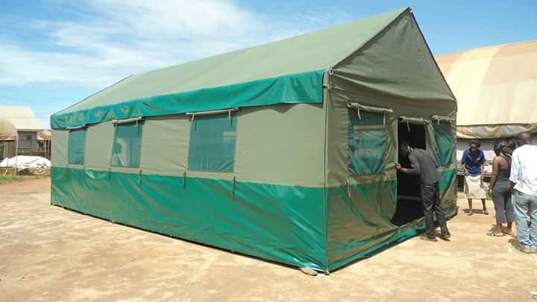

General terms and conditions.
- Goods offered shall be reviewed based on completeness and compliance of the quotation with the minimum specifications described above.
- The quotation that complies with all the specifications, requirements and offers the lowest price, as well as all other evaluation criteria indicated, shall be selected. Any offer that does not meet the requirements shall be rejected.
- Any discrepancy between the unit price and the total price (obtained by multiplying the unit price and quantity) shall be re-computed by IMA. The unit price shall prevail, and the total price shall be corrected. If the supplier does not accept the final price based on IMA’s re-computation and correction of errors, its quotation will be rejected.
- Mandatory documents to be included: (1) Brief company Profile (2) Product Brochures (3) Manufacturer’s Authorization of the Company as a Distributor and/or Sales Agent for supply, service and warranty for Laptop and branded accessories.
- IMA World Health shall, on fulfillment of the Delivery Terms, unless otherwise provided in this Purchase Order, make payment within 30 days of receipt of the Supplier's invoice for the goods and copies of the delivery documents specified in this Purchase Order.
- The prices shown in this Purchase Order may not be increased except by express written agreement of IMA World Health.
- IMA World Health shall have a reasonable time after delivery of the goods to inspect them and to reject and refuse acceptance of goods not conforming to this Purchase Order; payment for goods pursuant to this Purchase Order shall not be deemed an acceptance of the goods.

- EVALUATION CRITERIA

IMA World Health will evaluate bids that meet the minimum technical requirements on the basis of

No. | Criteria | Scoring | Weight
 | Meet Technical Specification
 | Price
 | Lead Time
 | Past Performance
 | Other Factors

It is anticipated that the award will be made on a best value analysis. However, IMA World health reserves the right to conduct negotiations with and/or request clarifications from any vendor prior to award at any time or change the evaluation criteria scoring/weighting at any time.

- TERMS AND CONDITIONS:
Issuance of this RFQ does not constitute an award commitment on the part of IMA World health, nor does it commit IMA World Health to pay for costs incurred in the preparation and submission of a bid.

- IMA World Health may contact bidders to confirm contact person, address, bid amount and to confirm that the bid was submitted for this solicitation.

- False Statements in the Bid: Bidders must provide full, accurate and complete information as required by this solicitation and its attachments.

- Conflict of Interest Disclosure: Bidders must provide disclosure of any past, present or future relationships with any parties associated with the issuance, review or management of this solicitation and anticipated award. Failure to provide full and open disclosure may result in IMA World Health having to re-evaluate selection of a potential Bidder.

- Right to Select/Reject IMA World Health reserves the right to select and negotiate with those firms it determines, in its sole discretion, to be qualified for competitive proposals and to terminate negotiations without incurring any liability. IMA World Health also reserves the right to reject any or all proposals received without explanation.

- Reserved rights: All RFQ responses become the property of IMA World Health and IMA Health reserves the right in its sole discretion to:
- To disqualify any offer based on Bidder’s failure to follow solicitation instructions;
  - To waive any deviations by Bidder from the requirements of this solicitation that in IMA’s opinion are considered not to be material defects requiring rejection or disqualification; or where such a waiver will promote increased competition.
- Extend the time for submission of all RFQ responses after notification to all Bidders.
  - Terminate or modify the RFQ process at any time and re-issue the RFQ to whomever IMA World Health deems appropriate.
- Issue an award based on the initial evaluation of offers without discussion; and
- Award only part of the activities in the solicitation or issue multiple awards based on solicitation activities.

QUOTATION VALIDITY:
Quotation should be valid for [30 days] days from the RFQ due date. This includes, but is not limited to, cost, pricing, terms and conditions, service levels and all other information. If your firm is awarded the contract, all information in the RFQ and negotiation process is contractually binding.

DELIVERY LOCATION AND LOGISITCS.
Deliver location: Nyambor & Ayod – South Sudan

DELIVERY TIMELINE:
Immediately after contract issuance.
QUESTIONS / CLARIFICATION REQUESTS:
n case you may have questions about any terms or requested item specification, please feel free to contact us via email. southsudanprocurement@imaworldhealth.org

Please contact: +211 920292868

- SUBMISSION INSTRUCTION(S):
You are requested to submit signed and dated offers to the office specified in this solicitation at or before the exact time specified in this solicitation.

Quotations may be submitted on Bidder’s letterhead and signed by the authorized company officer.

All quotations must be submitted to southsudanprocurement@imaworldhealth.org
ATTACHMENT B. QUOTE COVER SHEET

Vendor Name: _____________________________
Physical address: ___________________________
City, State, Zip: _____________________________
Primary Contact: ____________________________
Tel: _______________________________________
Fax: _______________________________________
Email: ______________________________________
Name of Authorized Official to Sign Contract: _______________________________
Title of Authorized Official: ______________________________________________

Certification: I certify that information provided is true and correct. The offer is valid for a minimum of XXX days.
Signature: _____________________________
Date: _________________________________

ATTACHMENT C. PAST PERFORMANCE

Complete the table below. Please include contact information for past customers that can provide professional references for your organization.

VENDOR NAME: ___________________________

# | Reference Contact Name | Organization Name | Telephone | Email | Date Services Performed | Type of Services Performed

LEGAL AND FINANCIAL CAPACITY FOR PERFORMANCE

Offerors should provide the following:

- Evidence of Offeror’s legal company registration, incorporation or license to do business issued by a competent authority in the country of registration.
- Audited financial statements for the previous fiscal year.
- Past Performance references from three previous customers for supply of similar goods as included in this RFQ. Contact details should be included.

