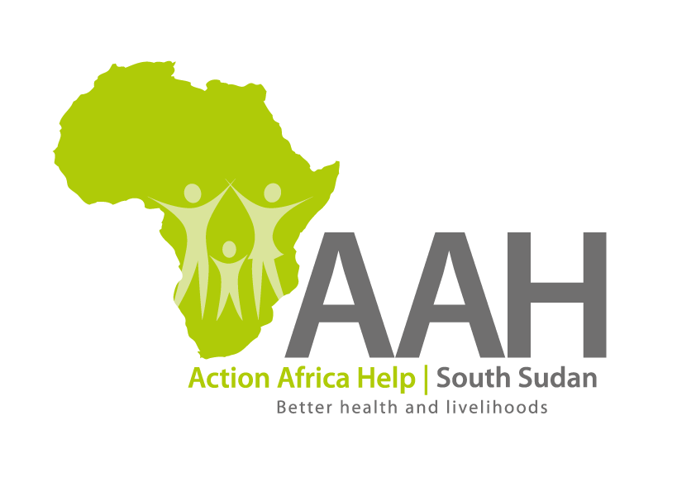
AAHI-South Sudan
Juba Office: Hai Gabat – Opp JIT Supermarket
Behind South Sudan Customs, Tel: +211 925 478 457
Email: ssudan@actionafricahelp.org
Website: www.actionafricahelp.org

INVITATION TO TENDER

Background
Action Africa Help International (AAH-I) is a nongovernmental and nonprofit making Organization operating in South Sudan with a mission to support disadvantaged Communities to sustainably improve their standard of living through Community empowerment approach in partnership with stakeholders. AAH-I implements Primary Health Care, Agriculture, Humanitarian aid projects and Capacity Building.

The organization is calling for BOQs from reputable companies for the provision of labour and materials for improvement of various construction works at the AAH-I /UNHCR way station Jebel.

 | DETAILS | LOCATION OF THE TENDER
1 | Provision of labour and materials for improvement of various construction works at the AAH-I /UNHCR way station Jebel. | Tender details to be picked from AAHI/UNHCR Logistic base

The deadline for submission is Thursday the 20th October, 2022, at 12:00 pm Local Time.

More information on the tender to be picked from AAHI/UNHCR Juba logistics base and

