Date: 3rd Jun 2020

Christian Mission for Development (CMD) is a registered non-profit, non-governmental, multi-sectoral relief and development organization dedicated to fighting poverty and injustices; and to enhance provision of holistic social services to reduce human suffering. CMD was established in 2005 to equip people with skills and to facilitate relief and development assistance to communities in need with special focus on women, children and youth initiatives

REQUEST FOR QUOTE

Deadline for submission of Quotation is 10th Jun 2020- by 05:00PM

Send to:
Christian Mission for Development
Tongpiny plot 157 BK III 3RD, Class Residential Area
Next to Catholic University
Juba, South Sudan

OR

By Email:
cmdlogs@cmdafrica.org

RFQ No: CMD/FSL-2020-02, Supply of storage PVC Tents for storage.
Christian Mission for Development- CMD wishes to contract a legally recognized service provider (company) for the supply of PVC Tents for storage to CMD Juba as listed below: -

Item | Specifications | Unit | Quantity
1. | TPVC Tent – 3x4m  General  3x4 Storage Tent / Shelter w. ground frame, PVC 500 g/m² white  - Fixing floor frame - flexibly removable if required  - With tear-resistant patterned inner fabric  - Bolted screw connection  Materials and thicknesses  Roof tarpaulin: approx. 500 g/m²; 100 % PVC  Side panels: approx. 500 g/m²  Steel pipes: approx. 38 mm  Wall thickness of poles: approx. 1.2 mm  Steel pole connectors: approx. 42 mm  Wall thickness of connectors: approx. 1.4 mm  Product sizes:  Width: approx. 3.00 m  Length: approx. 4.00 m  Lateral height: approx. 2.00 m  Ridge height: approx. 2.9 m  Leg distance (for max. side entrance width): approx. 2 m  WxL gate 1: approx. 2.0 x 2.0 m  WxL gate 2: approx. 1.0 x 2.0 m  Weather resistance:  100% waterproof  UV-resistant:  UV sun protection factor:- 80+ | PC | 3

See Photos:

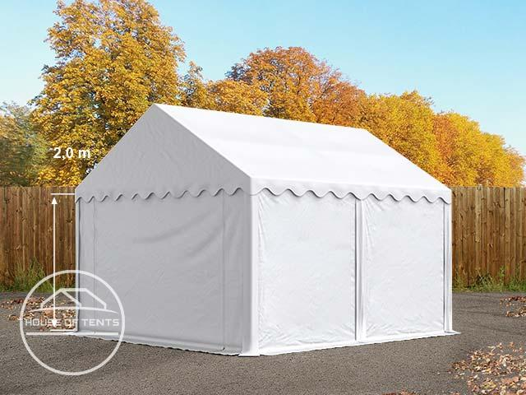

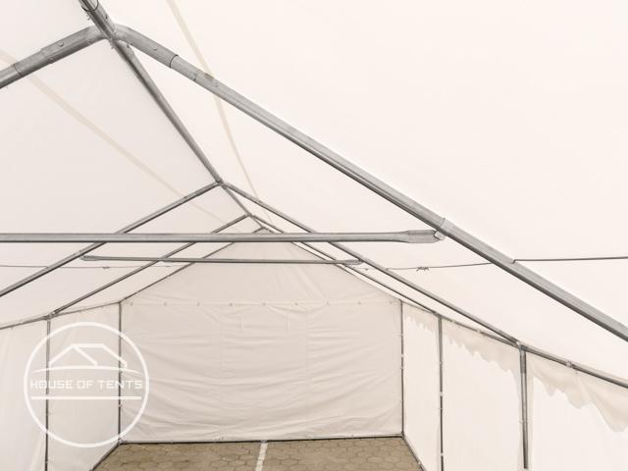

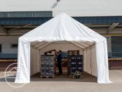

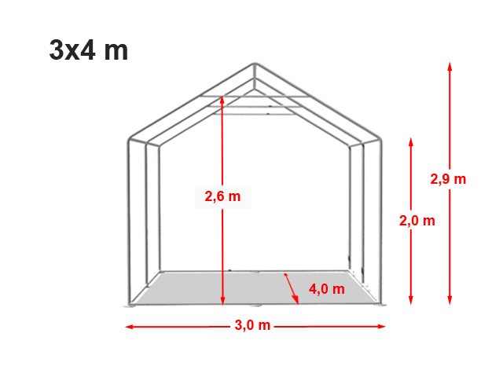
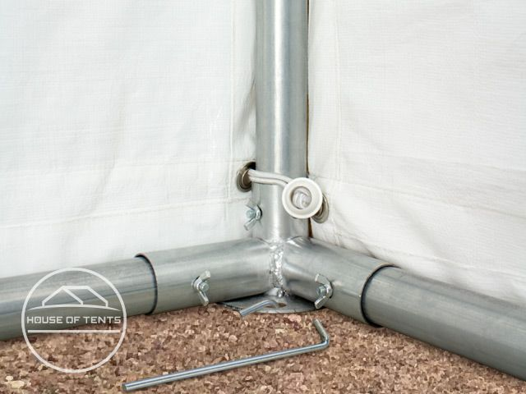
Diameter foot plate approx. 11 cm

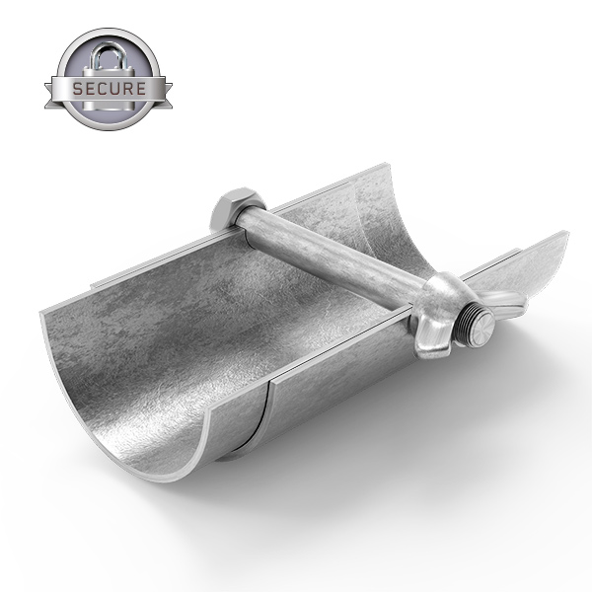Bolts and screws

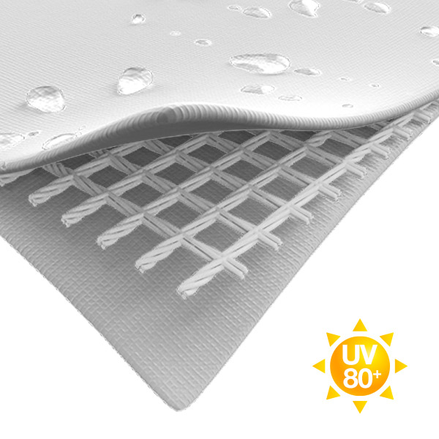With tear-resistant patterned inner fabric.

Statement of compliance with Terms and conditions.

Delivery Terms | To be delivered to the specified location and delivery period to be specified
Payment Terms | Bank transfer/ Cheque
Validity of Quotation | 90 days
Currency of prize | USD
Location of delivery | Juba, CMD Office
Cost | All cost Inclusive up to delivery point(Juba)
Warranty and After sales requirement | Warranty and After - sales services, details to be indicated. Minimum -1-year warranty on both parts and labor.  Services unit to be provided when the purchased unit is under repair.

