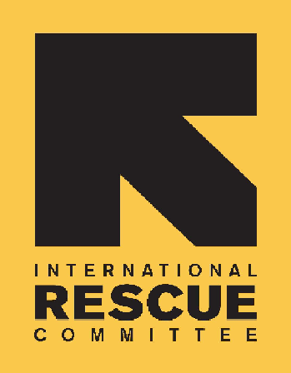
INTERNATIONAL RESCUE COMMITTEE, INC.

BID NOTICE

Founded in 1933, the International Rescue Committee is a global humanitarian leader that helps people whose lives and livelihoods are shattered by conflict and disaster to survive, recover, and gain control of their future.

The IRC has been operating in South Sudan since 1989. The IRC is registered and obtained Certificates of NGO operation from the Relief & Rehabilitation Commission (RRC) under serial No:020. The IRC is currently working in Rumbek, Ganyiel, Bentiu, Koch, AjoungThok, Malualkon, Panthou (Aweil South), Maban, Renk and in Juba. The regular sectors in IRC South Sudan are Health, Nutrition, Child Protection, Women Protection & Empowerment, Governance, Protection Mainstreaming, Economic Recovery & Development.

The IRC is issuing Request for Proposals (RFPs) to solicit competitive sealed bids to establish a contract with a reputable company for the provision of the following services for IRC South Sudan.

No: | Description of goods/service required | Location/ Field Site | Category ID#
1 | NON-FOOD ITEMS (NFIs | Malualkon Field Office | IRC/SS/AWL/MPA/2025/06
2 | BUILDING AND HARDWARE MATERIALS | Malualkon Field Office | IRC/SS/AWL/MPA/2025/04
3 | FOOD ITEMS AND BEVERAGES | Malualkon Field Office | IRC/SS/AWL/MPA/2025/03
4 | STATIONERY | Malualkon Field Office | IRC/SS/AWL/MPA/2025/05
5 | PETROLUEUM PRODUCTS (Diesel & Petrol) | Malualkon Field Office | IRC/SS/AWL/MPA/2025/02
6 | VEHICLE HIRE SERVICES | Malualkon Field Office | IRC/SS/AWL/MSA/2025/04
7 | RFI for Borehole Drilling and Repairs | Malualkon Field Office
8 | Audit Services | Juba Office | IRC/SS/AWL/MSA/2025/03

Interested and suitably qualified suppliers may request the complete tender documents (RFP) from the IRC Malualkon Field Office in Northern Bahr el Ghazal for all Malualkon tenders OR request them from ss-procurement@rescue.org during office hours between 0800hrs and 1630hrs.

NB for Juba based Tender to be requested through the above email only.

Offers to the above-mentioned categories will not be accepted after cut-off time 1630hrs (South Sudan Local time) on the 11th of June 2025. Instructions on how to submit your proposals are provided in the tender documents.

Please quote the category I.D# as the subject of your Proposal.

