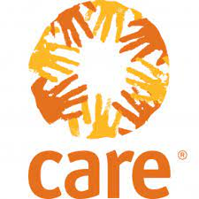
South Sudan- Juba
NPA Building, 3rd Floor,
Martyrs street
Juba South Sudan
P.O.BOX 302
BID NOTICE
REF: Request for Proposals – Medical Insurance, Group Life & GPA Insurance FY 2021-2022.
CARE in South Sudan is currently seeking for qualified and suitable insurance companies within South Sudan to offer Medical Insurance, Group Life & Group Personal Accident Insurance covers for its national staff for a one-year period starting 1st July,2021 through 30th June, 2022.
For those interested in bidding, please send an email to the addresses below requesting for the full tender dossier from 8:00AM to 5:00PM between Friday 11th June, 2021 to Tuesday 15th June, 2021. Please note that the DEADLINE for all bidders to submit completed bid documents is Thursday 17th June, 2021 at 4.30pm.
- Gideon.Masesi@care.org
- Francis.Mette@care.org
- Silvia.Konga@care.org
- info@edge-insure.com

