Title | Goods | RFQ Ref. No. | RFQ: WCO/SSD/GOODS/WATER QUALITY/446/EPR/2025 – PROCUREMENT OF WATER QUALITY TESTING KITS.
Published Date | 14/10/2025 | Closing Date & Time | 20/10/2025 @ 12:00 Noon
Contact | afwcossprocurement@who.int

1. Requirements

The World Health Organization (WHO) is seeking offers for Goods…. Your organization/company is invited to submit a proposal for the Service listed below in response to this Request for Quotation (RFQ).
- Your offer should comply with the Specifications described below.
- Variations from initial specifications must be precisely indicated.
- Please read carefully and comply with all points, otherwise your offer may be disqualified.

2. Proposal

Your quotation should contain and state:
- Acceptance of WHO General Purchasing Conditions (attached)
- Self-Declaration Form (attached)
- Net prices valid for a minimum of [three months] from the date of the offer
- Unit cost(s), indicating the United Nations convertible currency used (preferably US Dollars).

The proposal shall be submitted to WHO in writing no later than [14.10.2025] at 12:00 Noon. hours Juba time (“the closing date”), by email at the Contact address. afwcossprocurement@who.int

Each proposal shall be marked Ref: RFQ: WCO/SSD/GOODS/WATER QUALITY/446/EPR/2025 – PROCUREMENT OF WATER QUALITY TESTING KITS. and be signed by a person or persons duly authorized to represent the bidder, to submit a proposal and to bind the bidder to the terms of this RFQ.

A. Delivery details (if known)

Address Consignee

 | B. Specifications: Water quality testing kits.
Description / Product information | Norms & Standards (if  applicable) | Qty
Potatech + (PTW10480) | Potatech + (PTW10480) Wagtech | 2
Potatest Dual (PTW10020) | Potatest Dual (PTW10020) Wagtech | 1
Specifications | 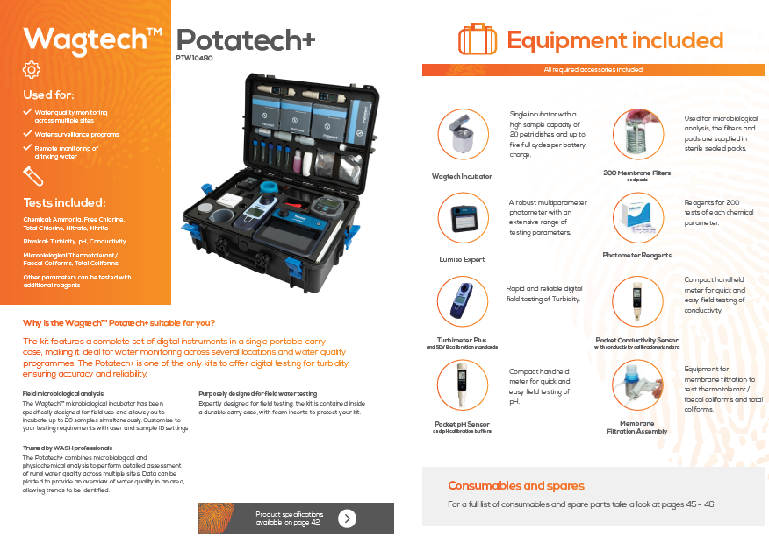
Specifications | 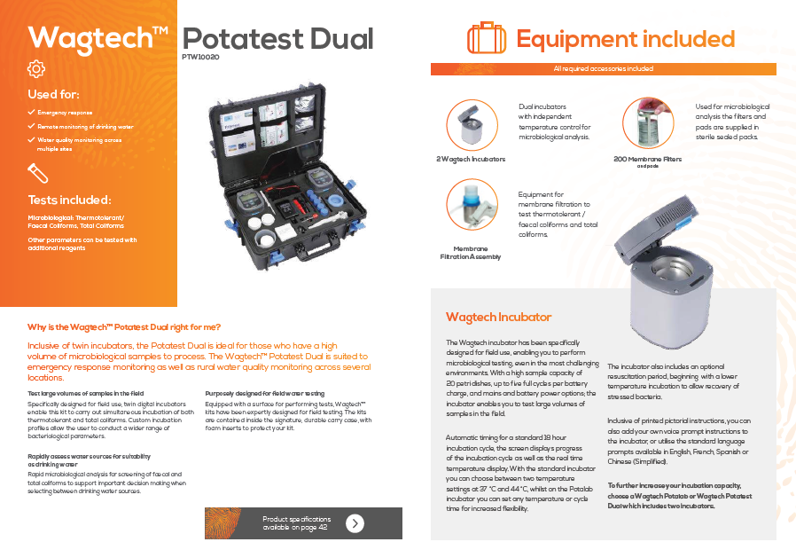

C. Additional information
C.1 Special order requirements
Preferred mode of shipment:
AIR SEA N/A
Requirements for INCOTERMs other than CIP (Port of Destination):
N/A
Special import or export requirements (chambered Certificates of Origin, etc.):
N/A
Customized packaging/printing for the order (please describe):
N/A
C.2 Procurement purpose (please check box that apply)
Emergency Pre-positioning Other
C.3 Distribution plan availability
(if yes, please check the box) N/A

WHO Payment terms are:

For the Goods: 30 (thirty) days from date of invoice

For installation and training: 30 (thirty) days from date of invoice after reception of confirmation from End User.

We look forward to receiving your response to this RFQ.
Each proposal shall be marked Ref: RFQ: WCO/SSD/GOODS/WATER QUALITY/446/EPR/2025 – PROCUREMENT OF WATER QUALITY TESTING KITS. and be signed by a person or persons duly authorized to represent the bidder, to submit a proposal and to bind the bidder to the terms of this RFQ.

WHO may, at its own discretion, extend the closing date for the submission of proposals by notifying all bidders thereof in writing.

Any proposal received by WHO after the closing date for submission of proposals may be rejected.

The offer outlined in the proposal must be valid for a minimum period of 90 calendar days after the closing date. A proposal valid for a shorter period may be rejected by WHO. In exceptional circumstances, WHO may solicit the bidder’s consent to an extension of the period of validity. The request and the responses thereto shall be made in writing. Any bidder granting such an extension will not, however, be permitted to otherwise modify its proposal.

The bidder may withdraw its proposal any time after the proposal’s submission and before the above mentioned closing date, provided that written notice of the withdrawal is received by WHO via afwcossprocurement@who.int as provided above, before the closing date.

No proposal may be modified after its submission, unless WHO has issued an amendment to the RFQ allowing such modifications.

No proposal may be withdrawn in the interval between the closing date and the expiration of the period of proposal validity specified by the bidder in the proposal (subject always to the minimum period of validity referred to above).

WHO may, at any time before the closing date, for any reason, whether on its own initiative or in response to a clarification requested by a (prospective) bidder, modify the RFQ by written amendment. Amendments could, inter alia, include modification of the project scope or requirements, the project timeline expectations and/or extension of the closing date for submission.

All prospective bidders that have received the RFQ will be notified in writing of all amendments to the RFQ and will, where applicable, be invited to amend their proposal accordingly.

3. Evaluation
Before conducting the technical and financial evaluation of the proposals it has received, WHO will perform a preliminary examination of these proposals to determine whether they are complete, whether any computational errors have been made, whether the documents have been properly signed, and whether the proposals are generally in order. Proposals which are not in order as aforesaid may be rejected.

Please note that WHO is not bound to select any bidder and may reject all proposals. Furthermore, since a contract would be awarded in respect of the proposal which is considered most responsive to the needs of the project concerned, due consideration being given to WHO’s general principles, including economy and efficiency, WHO does not bind itself in any way to select the bidder offering the lowest price.

WHO may, at its discretion, ask any bidder for clarification of any part of its proposal. The request for clarification and the response shall be in writing. No change in price or substance of the proposal shall be sought, offered or permitted during this exchange.

4. Award
WHO reserves the right to:

- Award the contract to a bidder of its choice, even if its bid is not the lowest;
- Award separate contracts for parts of the work, components or items, to one or more bidders of its choice, even if their bids are not the lowest;
- Accept or reject any proposal, and to annul the solicitation process and reject all proposals at any time prior to award of contract, without thereby incurring any liability to the affected bidder or bidders and without any obligation to inform the affected bidder or bidders of the grounds for WHO's action;
- Award the contract on the basis of the Organization’s particular objectives to a bidder whose proposal is considered to be the most responsive to the needs of the Organization and the activity concerned;
- Not award any contract at all.

WHO has the right to eliminate bids for technical or other reasons throughout the evaluation/selection process. WHO shall not in any way be obliged to reveal, or discuss with any bidder, how a proposal was assessed, or to provide any other information relating to the evaluation/selection process or to state the reasons for elimination to any bidder.

NOTE: WHO is acting in good faith by issuing this RFQ. However, this document does not oblige WHO to contract for the performance of any work, nor for the supply of any products or services.

At any time during the evaluation/selection process, WHO reserves the right to modify the scope of the work, services and/or goods called for under this RFQ. WHO shall notify the change to only those bidders who have not been officially eliminated due to technical reasons at that point in time.

WHO reserves the right at the time of award of contract to extend, reduce or otherwise revise the scope of the work, services and/or goods called for under this RFQ without any change in the base price or other terms and conditions offered by the selected bidder.

WHO also reserves the right to enter into negotiations with one or more bidders of its choice, including but not limited to negotiation of the terms of the proposal(s), the price quoted in such proposal(s) and/or the deletion of certain parts of the work, components or items called for under this RFQ.

Within 30 days of receipt of the contract, the successful bidder shall sign and date the contract provided to it by WHO, and return it to WHO according to the instructions provided at that time. If the bidder does not accept the contract terms without changes, then WHO has the right not to proceed with the selected bidder and instead contract with another bidder of its choice.

All bidders must adhere to the UN Supplier Code of Conduct, which is available at the following link: https://www.un.org/Depts/ptd/sites/www.un.org.Depts.ptd/files/files/attachment/page/2014/February%202014/conduct_english.pdf , and should submit a signed Self-Declaration Form (see attached).

WHO reserves the right to publish (e.g. on the procurement page of its internet site) or otherwise make public the contractor’s name and address, information regarding the contract, including a description of the goods or services provided under the contract and the contract value.

Any and all of the contractor's (general and/or special) conditions of contract are hereby explicitly excluded from the contract, i.e., regardless of whether such conditions are included in the contractor's offer, or printed or referred to on the contractor's letterhead, invoices and/or other material, documentation or communications.

Self- Declaration Form - RFQ: WCO/SSD/GOODS/WATER QUALITY/446/EPR/2025 – PROCUREMENT OF WATER QUALITY TESTING KITS.

Applicable to private and public companies

<COMPANY> (the “Company”) hereby declares to the World Health Organization (WHO) that:

- it is not bankrupt or being wound up, having its affairs administered by the courts, has not entered into an arrangement with creditors, has not suspended business activities, is not the subject of proceedings concerning the foregoing matters, and is not in any analogous situation arising from a similar procedure provided for in national legislation or regulations;
- it is solvent and in a position to continue doing business for the period stipulated in the contract after contract signature, if awarded a contract by WHO;
- it or persons having powers of representation, decision making or control over the Company have not been convicted of an offence concerning their professional conduct by a final judgment;
- it or persons having powers of representation, decision making or control over the Company have not been the subject of a final judgment or of a final administrative decision for fraud, corruption, involvement in a criminal organization, money laundering, terrorist-related offences, child labour, human trafficking or any other illegal activity;
- it is in compliance with all its obligations relating to the payment of social security contributions and the payment of taxes in accordance with the national legislation or regulations of the country in which the Company is established;
- it is not subject to an administrative penalty for misrepresenting any information required as a condition of participation in a procurement procedure or failing to supply such information;
- it has declared to WHO any circumstances that could give rise to a conflict of interest or potential conflict of interest in relation to the current procurement action;
- it has not granted and will not grant, has not sought and will not seek, has not attempted and will not attempt to obtain, and has not accepted and will not accept any direct or indirect benefit (finanical or otherwise) arising from a procurement contract or the award thereof.
The Company understands that a false statement or failure to disclose any relevant information which may impact upon WHO's decision to award a contract may result in the disqualification of the Company from the bidding exercise and/or the withdrawal of any proposal of a contract with WHO. Furthermore, in case a contract has already been awarded, WHO shall be entitled to rescind the contract with immediate effect, in addition to any other remedies which WHO may have by contract or by law.

Entity Name: | …………………………………………………………………………………………………
Mailing Address: | …………………………………………………………………………………………………  …………………………………………………………………………………………………
Name and Title of duly authorized representative: | …………………………………………………………………………………………………
Signature:
Date: | …………………………………………………………………………………………………

https://treasury.un.org/operationalrates/default.php

