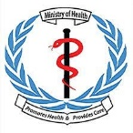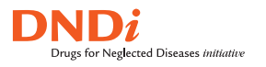

Terms of Reference (ToR) for a STTA consultant to support evidence review, documentation and updating of the Visceral leishmaniasis (VL) treatment guidelines with the goal of reducing morbidity and mortality from VL in South Sudan and the region.

CONTEXT

Visceral leishmaniasis (VL) – also known as kala-azar – is a neglected tropical disease spread by the bite of the sandfly. Currently, the highest VL burden is in Eastern Africa (Djibouti, Eritrea, Ethiopia, Kenya, Somalia, South Sudan, Sudan, and Uganda), accounting for 57% of VL cases reported globally in 2020. Most affected populations live in remote areas far from health facilities, where VL remains a neglected and under-reported disease that impoverishes many of the most vulnerable.

EVALUATING AN ALTERNATIVE TREATMENT REGIMEN FOR VISCERAL LEISHMANIASIS IN EASTERN AFRICA: A Phase III trial to assess the safety and efficacy of miltefosine plus paromomycin,

DNDi and AfriKADIA consortium partners conducted a Phase III clinical trial for visceral leishamniasis patients in Ethiopia, Kenya, Sudan, and Uganda to assess the safety and efficacy of miltefosine plus paromomycin (MF+PM) as an alternative to the standard of care, sodium stibogluconate plus paromomycin (SSG+PM), in Eastern Africa. The trial found that the MF+PM combination therapy was as effective as SSG+PM but with fewer injections, a shorter treatment duration, and no risk of SSG-associated cardiotoxicity. MF+PM also reduced the risk of subsequent post-kala azar dermal leishmaniasis, which is a source of ongoing VL transmission in communities. Based on the evidence that it is an equally effective but more patient-friendly treatment, MF+PM could be a future alternative therapy for patients with VL in Africa

WHY WAS THIS CLINICAL TRIAL CONDUCTED?
Since 2010, the first-line treatment for VL in Eastern Africa has been a 17-day sodium stibogluconate plus paromomycin (SSG+PM) combination therapy. It is an improvement over the previous 30-day SSG monotherapy, but the treatment is still lengthy and painful, requiring patients to be hospitalized for the entire 17-day duration of treatment, with two daily injections per day, given one after another. More importantly, although rare, the antimonial drug SSG may present life threatening side effects such as cardiotoxicity, hepatotoxicity, and pancreatitis. There is an urgent need for alternative treatments that are suitable to be used in the remote areas where VL typically occurs and with children, who represent more than half of patients needing treatment, as well as the elderly, who are at highest risk of SSG-related toxicity. Miltefosine (MF) is the only oral treatment available for VL. In India and Bangladesh, a 10-day combination of MF with paromomycin (PM) has shown cure rates at 6 months ranging from 96.9% to 98.7%, making it an attractive option to evaluate in Eastern Africa. In addition, the absence of antimonial-related toxicity, fewer required injections, and shorter treatment duration would make MF+PM a better option for patients with VL. This trial assessed the safety and efficacy of MF+PM as an alternative to the standard of care, SSG+PM, in Eastern Africa.

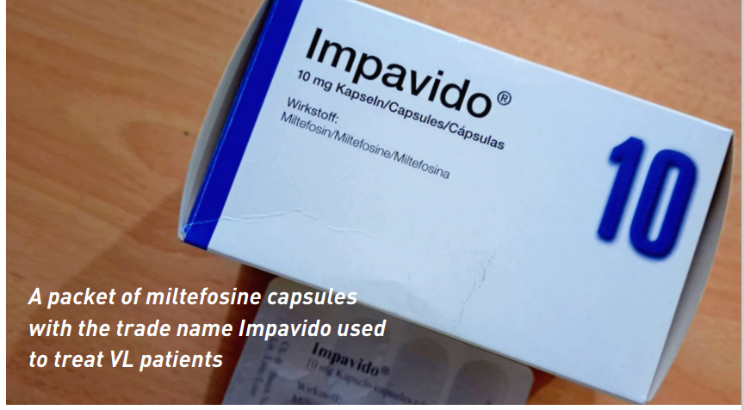

HOW AND WHERE WAS THIS TRIAL CONDUCTED?
The purpose of this trial was to determine the safety and efficacy of a combination regimen of oral miltefosine plus paromomycin (MF+PM) for 14 days as compared to the standard of care SSG+PM 17-day treatment for primary VL patients.
The study began in 2018, conducted by DNDi and partners from the AfriKADIA Consortium with funding from the European and Developing Countries Clinical Trials Partnership (EDCTP). There were 439 participants in total, both children and adults, from seven sites in Sudan (Doka, Um El Kher and Tabarak Allah), Kenya (Kacheliba), Ethiopia (Gondar and Abdurafi), and Uganda (Amudat). Study participants were randomly assigned to receive one of the two treatments:
- Paromomycin (20 mg/kg/day) via intramuscular injection for 14 days and miltefosine (allometric dosing) twice per day taken orally for 14 days, or
- Sodium stibogluconate (20 mg/kg/day) IV/IM and paromomycin (15 mg/kg/day) via intramuscular injection for 17 days.
- The primary efficacy endpoint was definitive cure at six months follow-up, defined as absence of clinical signs and symptoms of VL after 210 days and no rescue treatment during the trial.

WHAT WERE THE RESULTS?
The study showed that a MF+PM combination achieved similar cure rates at six months follow-up as the standard of care SSG+PM in adult and paediatric patients with VL in Eastern Africa (91.2% and 91.8%, respectively). MF+PM also reduced the risk of subsequent post-kala azar dermal leishmaniasis (PKDL) from 20.9% in those treated with SSG+PM to just 4.4% in Ethiopia and Sudan. PKDL is a source of ongoing VL transmission in communities. MF+PM was well tolerated; the most common adverse event was mild vomiting related to miltefosine. MF+PM eliminates one painful daily injection and the potential life-threatening toxicity associated with the antimonial SSG, and it reduces the length of hospital stay from 17 to 14 days. Given that most patients are children, these are important benefits, making the treatment more patient-friendly than the current treatment. The main disadvantage is that MF+PM cannot be taken by pregnant women, and any women of child-bearing potential must take contraceptives during treatment and for five months after treatment. The new MF+PM combination would provide the Eastern African region with the first non-antimony-based treatment for uncomplicated VL, with increased suitability to be used in remote settings with limited access to health facilities. Based on the evidence that it is an equally effective but more patient-friendly treatment, MF+PM could be a future alternative therapy for patients with VL.

WHAT ARE THE NEXT STEPS?
The paper reporting on the results of this Phase III trial to assess the safety and efficacy of miltefosine plus paromomycin has been accepted for publication by Clinical Infectious Diseases journal (https://academic.oup.com/cid/article-lookup/doi/10.1093/ ).
DNDi and its partners will work to ensure availability of MF+PM as a VL treatment in Eastern Africa through the Leishmaniasis East Africa Platform (LEAP). DNDi will also work with local authorities and WHO to support evidence review and updating of the VL treatment guidelines with the ultimate goal of reducing morbidity and mortality from visceral leishmaniasis in the region.

Currently, DNDi is implementing the LeishAccess project whose objective is to improve access to care for leishmaniasis patients, including vulnerable groups, for the various forms of the disease (visceral leishmaniasis, cutaneous leishmaniasis, PKDL, and HIV/VL). Access activities are being carried out in Ethiopia, Kenya, South Sudan, Sudan, and Uganda.
- In South Sudan, IMA World Health with funding from DNDi, and in close cooperation with MoH, Director of the Case Management office, will deploy a short-term technical consultancy to support the new evidence review, documentation and updating of the VL treatment guidelines with the goal of reducing morbidity and mortality from visceral leishmaniasis (VL) in the in South Sudan

Based on the above, the objective of the STTA/Consultant.
- In close coordination with MoH – Director – Case Management, DNDi technical team, WHO, IMA and other visceral leishmaniasis (VL) stakeholders, support in the new evidence review, documentation and updating of the VL treatment guidelines with the goal of reducing morbidity and mortality from visceral leishmaniasis (VL) in the in South Sudan
Activities /Scope of Work
- Conduct Literature review on current diagnostics and treatment guidelines for VL in South Sudan
- Conduct VL stakeholder mapping and organize a VL stakeholder meeting to document MF/PM, new evidence on the management of VL, HIV/VL and PKDL. Act as rapporteur and steer group Literature review and feedback. Document key insights and new evidence shared.
- Review of VL partners planned activities for 2023/2024
- Review Current Diagnosis and Treatment guidelines and WHO Recommendations and review/identify and document areas to be aligned.
- Present a draft report on new evidence on the management of VL, HIV/VL and PKDL to the VL stakeholders, and steer discussions, seek critical inputs and recommendations.
- Present a validated evidence-based report on the management of VL, HIV/VL and PKDL for wider circulation and adoption.

Length of the consultancy: 21 working days.
Start date. 22nd September 2023.
Duty location: Juba.
Reports to: IMA South Sudan Country Director.

Required professional qualification, skills, and experience.
- High ability to use initiative, prioritize, multi-task, and work well under pressure to meet deadlines.
- Very clear and systematic thinking that demonstrates strong judgment and problem-solving competencies.
- Excellent communication skills in multicultural, multi-lingual environments
- Excellent communication, and public speaking skills, ability to convince and represent IMA and DNDi at high level events.
- Excellent management, negotiation, and advocacy skills
- High ability to exercise a high degree of independence to ensure program (SoW) delivery on time and explore new areas of activities.
- High ability to interact with internal and external stakeholders.
- High ability to articulate issues, and bring them out succinctly, stimulate inputs and consensus from multi-disciplinary stakeholders and cultivate buy-in of new evidence and products.

R& D Technical Skills
• Excellent knowledge of Clinical Research/Development
• Strong knowledge of Drug Discovery/Development
• Strong knowledge of Regulatory (GCP, GLP and GMP)
• Excellent knowledge of Disease/academia knowledge
• Excellent Technical writing skills (procedures, protocols, and reports)

Experience
• Minimum 5 years’ relevant experience in a Senior role, in clinical research or equivalent
• At least 5 years proven work experience in communicable disease prevention and control programs with more than one-year practical experience on leishmaniasis required; At least 2 years proven experience in leishmaniasis project management or other related public health activities preferred

Education
• Medical degree is highly desirable
• Master’s degree or Ph.D. in relevant field
• Formal training or certification as required by the function
- MSc or equivalent in a field relevant to vector control/public health Essential Application

Other Requirements
• Fluency in English and proficiency in Arabic
• Excellent knowledge of Microsoft Suite and generate a high-quality report.
• Qualified South Sudanese nationals are encouraged to apply

How to Apply:
Application and Selection process
All applications must be submitted through the email: southsudanprocurement@imaworldhealth.org

Before September 18th 2023.
The applications should consist of the following:
- CV of the team leader and company profile highlighting relevant experience.
- The company valid Operation license, Registration certificate and valid Tax Clearance Certificate.
- At least 3 certificates of completion of similar service with International NGOs in South Sudan.
- Proposed assignment methodology.
- Outline workplan.
- Financial proposal including the total cost for the assignment.
- Indicate the support services and/or referral resources that can be provided to the organization during and after the development of the system.

All the applications received will be screened internally by IMA World Health technical team for their completeness and for meeting the technical specifications, experience, required qualifications, budget, and timeline.

