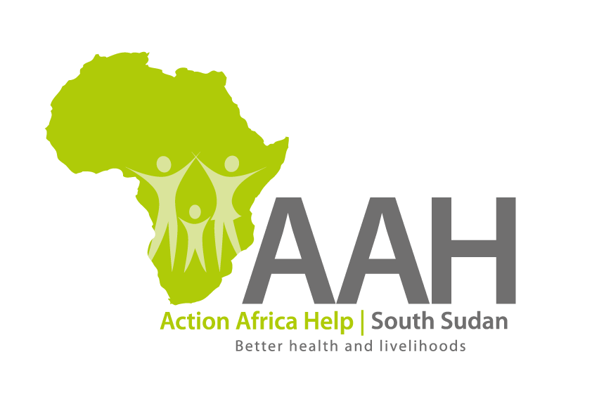
AAHI-South Sudan
Juba Office: Hai Gabat – Opp JIT Supermarket
Behind South Sudan Customs, Tel: +211 925 478 457
Email: ssudan@actionafricahelp.org
Website: www.actionafricahelp.org

INVITATION TO TENDER

Background
Action Africa Help International (AAH-I) is a nongovernmental and nonprofit making Organization operating in South Sudan with a mission to support disadvantaged Communities to sustainably improve their standard of living through Community empowerment approach in partnership with stakeholders. AAH-I implements Primary Health Care, Agriculture, Humanitarian aid projects and Capacity Building.

The organization is calling for quotations from reputable companies for provision of the following construction services in Maban.

No | DESCRIPTION
1. | Provision of labour and materials for construction of boundary perimeter wall fence at Bunj Hospital phase 1 (7425) | More information to be picked from AAHI/UNHCR Juba Logistics base or AAHI Maban Logistics base
2. | Provision of labour and materials for construction of boundary perimeter wall fence at Bunj Hospital phase 2 (7426) | “
3. | Supply of armco steel culverts (1200mm) | 50 M
4. | Supply of engine oil shell helix HXS Synthetic | 2000 litres

- REQUIREMENTS

Administrative Requirement:
Contractors are required to submit the following documents;
- Valid registration Certificate
- Valid Tax compliance certificate
- Operation License
Only registered company will be evaluated.
Technical Requirement
- Company Profile which should contain evidence of past experience in Maban
- Work schedule
- Bid Bond (as per the template shared)
- Signed general terms and conditions
Financial proposal
- Costed BOQ which should be on Company’s letterhead (for construction works)
- Price and Currency: The prices shall be in United States Dollars (USD).

- Quotation should be on Company’s letter head

- Submission of Quotes
The quotations shall be submitted in two separate envelopes (financial proposal and technical proposal) and in Hard copies in sealed envelopes on the address indicated below.

Submission Address
bids shall be submitted to:
AAH-I/UNHCR Logistic Base, Juba South Sudan
Near JIT Supermarket,
AAH-I South Sudan.

OR
AAH-I Maban Office
Maban Compound in Bunj
Maban

Please note, there will be no submission of several works in one envelope. Each works should have separate quote and envelope.

- Site visit/Inspection
The bidder is strongly advised to visit and examine the site(s) of works and its surrounding and obtain for himself, at his own expense, all information that may be necessary for preparing the tender and entering into contract. The bidder shall be fully responsible for the reliability and accuracy of all information so obtained.

- Registration for submission:
Please ensure that, you register your hand delivered quotation/bid with the Procurement department and drop it in the bid box yourself, before you leave the Procurement department in Juba or Logistics department in Jamjang. Each hand delivered quotation/bid must be registered individually on the bids submission forms which will be available at Procurement department/Logistics department. Unregistered quotation/bid will not be considered even if it is dropped in the tender box.

- Request for clarifications
Any request for clarification must be made in writing through the email: procurement.southsudan@actionafricahelp.org strictly and must be received not later than Friday the 18th February, 2022 at 12:00 pm Local Time.

- Deadline for submission of the quotation
The deadline for the submission of the quotes will be strictly on Monday the 28th February, 2022, at 12:00 pm Local Time.

- Evaluation criteria
Evaluation will be based on administrative, technical and financial requirements. Bidders who will fail to submit any of the documents requested at administrative level will be disqualified from technical and financial evaluation.

- Notification of the results
Only the successful and competitive bidder will be notified, and if you do not receive email communication within two weeks after the expiry of the deadline, consider your bid not successful.

- Language for the bids

The language for the bids shall be English only.

Disclaimer
This is only a Call for quotations and AAH-I South Sudan reserves the right to either amend or cancel it at any time with or without notice. In such cases, AAH-I South Sudan shall accept no liability whatsoever. The prospective bidder is wholly responsible for any and all costs related to the preparation and submission of their quotations.

The decision of the AAH-I South Sudan Procurement Review Committee shall be final.

