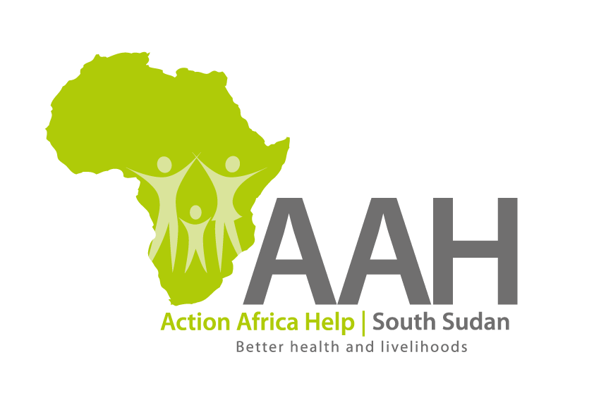
REQUEST FOR QUOTATION

Background
Action Africa Help International (AAH-I) is a nongovernmental and nonprofit making Organization operating in South Sudan with a mission to support disadvantaged Communities to sustainably improve their standard of living through Community empowerment approach in partnership with stakeholders. AAH-I implements Primary Health Care, Agriculture, Humanitarian aid projects and Capacity Building.

The organization is calling for quotations from reputable companies for servicing of two fuel pumps in Juba Logistic base. Interested bidders are requested to visit AAHI/UNHCR Juba Logistic base for assessment of the pumps.

REQUIREMENTS

Price and Currency: The prices shall be in United States Dollars (USD).

Submission of Quotes

The quotations shall be submitted in Hard copies in sealed envelopes, and there shall be no submission of quotes in soft copies.

Submission Address

Bids shall be submitted to:
AAH-I/UNHCR Logistic Base Juba South Sudan
Near JIT Supermarket, the envelope should be labeled
Read: fuel pumps maintenance
AAH-I South Sudan.

Registration for submission:

Please ensure that, you register your hand delivered quotation/bid with the Procurement department and drop it in the bid box yourself, before you leave the Procurement department.
Each hand delivered quotation/bid must be registered individually on the bids submission forms which will be available at Procurement department. Unregistered quotation/bid will not be considered even if it is dropped in the tender box.

Deadline for the submission of the quotation
The deadline for the submission of the quotes will be strictly on Monday the 5th September, 2022, at 12:00 pm Local Time.

Notification of the results
Only the successful and competitive bidder will be notified, and if you do not receive email communication within two weeks after the expiry of the deadline, consider your bid not successful.

Important note
There shall be supplier visit by the tender committee to ascertain that the selected bidders have capacity to meet AAH demand.

Language for the bids

The language for the bids shall be English only.

Disclaimer

This is only a Call for quotations and AAH-I South Sudan reserves the right to either amend or cancel it at any time with or without notice. In such cases, AAH-I South Sudan shall accept no liability whatsoever. The prospective bidder is wholly responsible for any and all costs related to the preparation and submission of their quotations.

The decision of the AAH-I South Sudan Procurement Review Committee shall be final.

