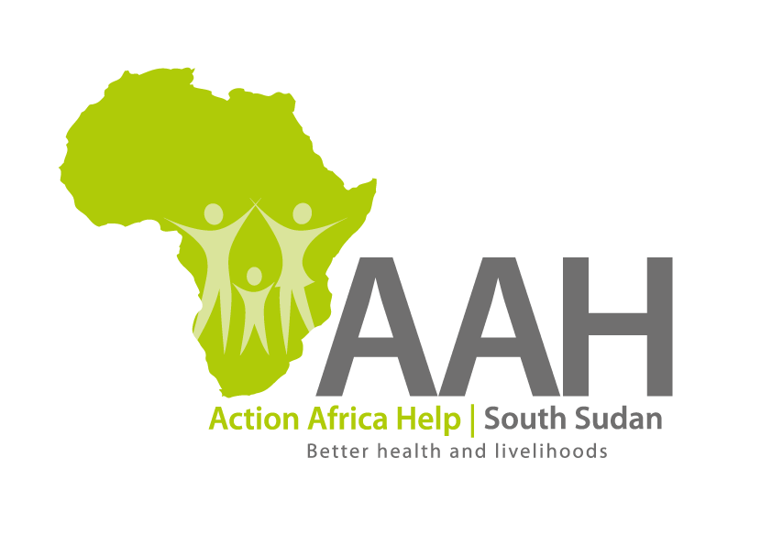
AAHI-South Sudan
Juba Office: Hai Gabat – Opp JIT Supermarket
Behind South Sudan Customs, Tel: +211 925 478 457
Email: ssudan@actionafricahelp.org
Website: www.actionafricahelp.org

INVITATION TO TENDER

Background
Action Africa Help International (AAH-I) is a nongovernmental and nonprofit making Organization operating in South Sudan with a mission to support disadvantaged Communities to sustainably improve their standard of living through Community empowerment approach in partnership with stakeholders. AAH-I implements Primary Health Care, Agriculture, Humanitarian aid projects and Capacity Building.

The organization is calling for quotations from reputable companies for provision of the following construction services in Juba.

No | DESCRIPTION
1 | Provision of labour And Materials for the Construction of Septic tank in Juba Logistic base | More information to be picked from AAHI/UNHCR Logistic Base in Juba

The deadline for submission is Wednesday the 8th June, 2022, at 4:00 pm Local Time.

More information on the tender to be picked from AAHI/UNHCR Juba logistic base

