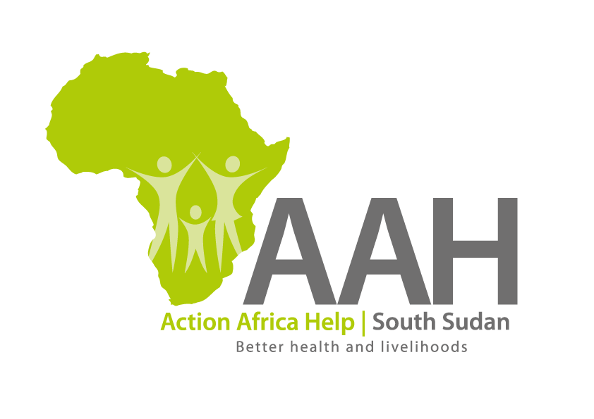
INVITATION TO BID

Background
Action Africa Help International (AAH-I) is a nongovernmental and nonprofit making Organization operating in South Sudan with a mission to support disadvantaged Communities to sustainably improve their standard of living through Community empowerment approach in partnership with stakeholders. AAH-I implements Primary Health Care, Agriculture, Humanitarian aid projects and Capacity Building.

The organization is inviting bids from reputable transport companies for provision of road transport with an aim of getting into a long-term framework agreement.

NO | DESCRIPTION | Capacity of the Truck
1 | Provision of road transport for transportation of assorted supplies from Juba to Jamjang | 40mt truck

Interested bidders can collect detailed ITB from AAHI/UNHCR Logistic base OR request through procurement.southsudan@actionafricahelp.org.

The deadline for the submission of the bids is 19th May, 2026.

