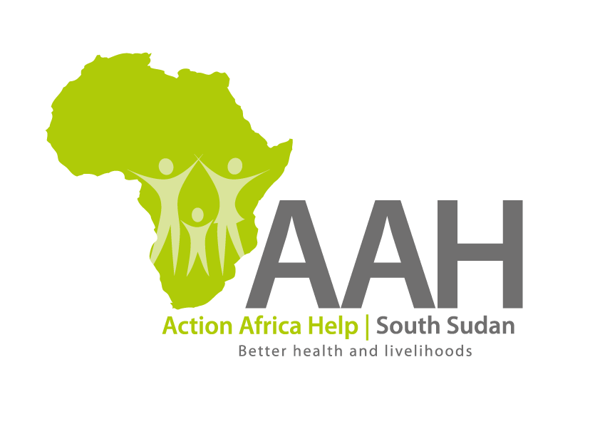AAH South Sudan

Juba Office: **Hai Gabat – Opp JIT Supermarket**

**Behind South Sudan Customs, Tel: +211 925 478 457**

**Email:** [**ssudan@actionafricahelp.org**](mailto:ssudan@actionafricahelp.org)

**Website:** [**www.actionafricahelp.org**](http://www.actionafricahelp.org)

|  |
| --- |
| **INVITATION TO TENDER** |

**Background**

Action Africa Help International (AAH-I) is a nongovernmental and nonprofit making Organization operating in South Sudan with a mission to support disadvantaged Communities to sustainably improve their standard of living through Community empowerment approach in partnership with stakeholders. AAH-I implements Primary Health Care, Agriculture, Humanitarian aid projects and Capacity Building.

The organization is inviting quotations from reputable companies for provision of the labor for construction services in jamjang and supply of hose assembly as indicated below:

|  |  |  |
| --- | --- | --- |
| **NO** | **DESCRIPTION** | **comment** |
| 1 | CONSTRUCTION OF 1ST BLOCK OF  POLICE OUT POST  IN JAMJANG CAMPS | BOQ to be picked from AAHI Juba Logistics Base or AAHI Jamjang Logistics base. |
| 2 | CONSTRUCTION OF 2ND BLOCK OF  POLICE OUT POST  IN JAMJANG CAMPS | BOQ to be picked from AAHI Juba Logistics Base or AAHI Jamjang Logistics base. |
| 3 | CONSTRUCTION OF 3RD BLOCK OF  POLICE OUT POST  IN JAMJANG CAMPS | BOQ to be picked from AAHI Juba Logistics Base or AAHI Jamjang Logistics base. |
| 4 | Hose assembly with male & female camlock (for sewage truck) | Details to be picked from AAHI Juba Logistics Base. |

Detailed ITB to be picked from AAHI/UNHCR Juba Logistic base/Jamjang Logistics Office during working hours.

Deadline for submission of the bids will be on **6th September, 2024** at **12:00pm.**