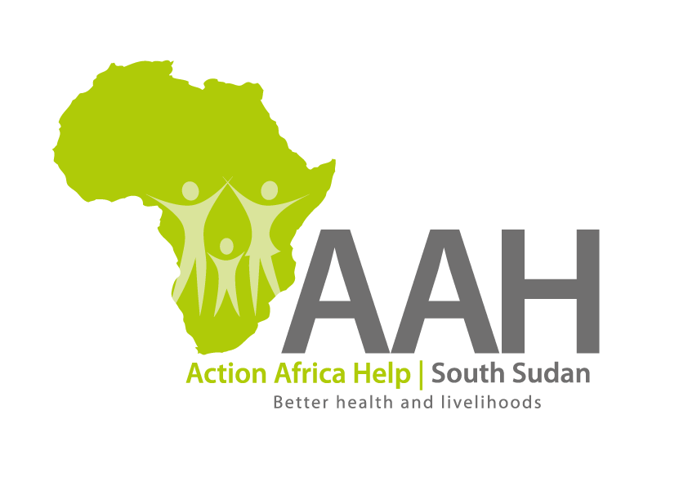
AAH-I South Sudan
Juba Office, off Munuki Road,
Next to South Sudan Civil Service Commission

CALL FOR PROPOSALS

Background
Action Africa Help International (AAH-I) is a nongovernmental and nonprofit making Organization operating in South Sudan with a mission to support disadvantaged Communities to sustainably improve their standard of living through Community empowerment approach in partnership with stakeholders. AAH-I implements Primary Health Care, Agriculture, Humanitarian aid projects and Capacity Building.

The organization is calling for quotations from reputable companies for provision of staff medical insurance cover as per TOR to be downloaded from the following websites:

AAHI website and NGO Forum

REQUIREMENTS
Rate and Currency: The rate shall be in United States Dollars (USD).

2. Eligibility and requirements:
2.1 Administrative requirements:
2.1.1 Valid certificate of incorporation as a business in South Sudan
2.1.2 Valid and certified certificate of registration as an Insurance Service Provider in South Sudan, issued by the relevant authority
2.1.3 Valid and certified registration with the Tax Regulatory Authority of South Sudan
2.1.4 Copy of Articles and Memorandum of Association
2.1.5 Proof of membership with Insurance regulatory body

2.2 Technical Requirements
2.2.1 Proof that the Service Provider has provided similar service to other Non-Governmental Organizations (NGOs).
2.2.2 Recommendations from past and current clients operating in the Republic of South Sudan (RSS) for the similar services provided.
2.2.3 Profile of current clients
2.2.4 Technical Proposal – that covers the following:
- Comprehensiveness of the proposed medical scheme, including enhanced benefits over and above those specified in the Scope of cover.
- Geographic Coverage / Service Network Coverage i.e. schedule of panel of hospitals by region. The bidder should have extensive and reputable network of hospitals, clinics, pharmacies and laboratories within easy reach of the members and their dependents. The bidder is expected to provide details of towns where the insurance company is represented and the appointed hospitals/clinics and panel of doctors approved by provider (East Africa Region) that can be accessed by AAHI employees and their dependents.
- Inclusion in the panel of hospitals, main or reputable private hospitals in major cities/towns.
- Case Management - The bidder is expected to demonstrate their strategy for case management, e.g. full time doctor, 24/7 Services.
- Claim Settlement / Turnaround Time - Provide details of the claim settlement as well as the turnaround time. This will also be used to review the performance for any future renewal of the contract.
2.2.5 Bank recommendation letter stating the financial capacity of the Service Provider during the last 18 months.
2.3 Financial Proposal (in US Dollars)
Insurance Companies are requested to provide TWO separate quotes for two options below;
- Option 1 “AS – IS” - The quote should provide price for the medical insurance cover “as is” or as specified in the minimum benefits packaged on the scope of the cover.
- Option 2: Enhanced Benefits - The above specified benefit package but with improved range of benefits (enhancements) BUT at the same price as what was quoted in Option 1 above. It is important to include in the proposal, details of the enhancements for purposes of comparisons.
3.0 Submission of quotes:
The quotations shall be submitted in Hard copies in sealed envelopes, and there shall be no submission of quotes in soft copies.
Submission Address

bids shall be submitted to:
AAH-I/UNHCR Logistic Base Juba South Sudan
Near JIT Supermarket, the envelope should be labeled
Read: PROVISION OF INSURANCE SERVICES
AAH-I South Sudan.

Registration for submission:

Please ensure that, you register your hand delivered quotation/bid with the Procurement department and drop it in the bid box yourself, before you leave the Procurement department.
Each hand delivered quotation/bid must be registered individually on the bids submission forms which will be available at Procurement department. Unregistered quotation/bid will not be considered even if it is dropped in the tender box.
Request for clarifications

Any request for clarification must be made in writing through the email: procurement.southsudan@actionafricahelp.org strictly and must be received not later than Thursday the 19th November, 2020 at 12:00 pm Local Time.

Deadline for the submission of the quotation
The deadline for the submission of the quotes will be strictly on Monday the 23rd November, 2020, at 12:00 pm Local Time.

Evaluation criteria

The evaluation factors will be comprised of the following criteria:
- PRICE. Lowest evaluated ceiling price (inclusive of option quantities).
- RESPONSIVENESS. bidder provides the most advantageous service delivery timelines, case management and claim settlements turnaround time, network coverage and overall responsiveness to the client’s needs
- TECHNICAL. Items/Services shall satisfy or exceed the specifications described in CFP.
- PAST PERFORMANCE - bidder can demonstrate his/her capability and resources to provide the items/services requested in this solicitation in a timely and responsive manner by detailing out their references

EVALUATION OF BIDS
The proposals will be evaluated in 3 Stages as follows:
Stage 1:
Administrative requirement. These are mandatory eligibility requirements to be met before the bidder can qualify for stage 2 of the evaluation – 10 points. The bidder must score all the points.

Stage 2:
Technical Evaluation - 80 points
Only bidders that score at least 60 points in Stage 2 will be qualify for Stage 3 - Financial Evaluation.

Stage 3:
Financial evaluation – 20 points

Notification of the results
Only the successful and competitive bidder will be notified, and if you do not receive email communication within two weeks after the expiry of the deadline, consider your bid not successful.

Language for the bids
The language for the bids shall be English only.

Disclaimer
This is only a Call for quotations and AAH-I South Sudan reserves the right to either amend or cancel it at any time with or without notice. In such cases, AAH-I South Sudan shall accept no liability whatsoever. The prospective bidder is wholly responsible for any and all costs related to the preparation and submission of their quotations.

The decision of the AAH-I South Sudan Procurement Review Committee shall be final.

